CHINOOK
MUSIC STORE ANALYSIS
BY - Souparna Maity
Objective Questions

1.Does any table have missing values or duplicates? If yes how would you handle it ?
Yes, tables customer, employee, track have missing values replaced with Unknown or None for categorical columns and replaced with ‘0’ for numerical columns and none of the tables have duplicate values.
-- 1. Checking for Nul values and duplicate values and handling them

SELECT * FROM album; -- album_id, title, artist_id
SELECT * FROM artist; -- artist_id, name
SELECT * FROM customer; -- customer_id, first_name, last_name, company, address, city, state, country, postal_code, phone, fax, email, support_rep_id
SELECT * FROM employee; -- employee_id, last_name, first_name, title, reports_to, birthdate, hire_date, address, city, state, country, postal_code, phone, fax, email
SELECT * FROM genre; -- genre_id, name
SELECT * FROM invoice; -- invoice_id, customer_id, invoice_date, billing_address, billing_city, billing_state, billing_country, billing_postal_code, total
SELECT * FROM invoice_line; -- invoice_line_id, invoice_id, track_id, unit_price, quantity
SELECT * FROM media_type; -- media_type_id, name
SELECT * FROM playlist; -- playlist_id, name
SELECT * FROM playlist_track; -- playlist_id, track_id
SELECT * FROM track; -- track_id, name, album_id, media_type_id, genre_id, composer, milliseconds, bytes, unit_price

-- checking missing values in album table

SELECT * FROM album
WHERE album_id IS NULL
OR title IS NULL
OR artist_id IS NULL;
-- NO MISSING VALUES

-- checking for duplicate values in album table

SELECT album_id,title,artist_id , COUNT(*) AS count
FROM album
GROUP BY album_id,title,artist_id
HAVING COUNT(*) > 1;
-- NO DUPLICATE VALUES

-- checking for missing values in artist

SELECT * FROM artist
WHERE artist_id IS NULL
OR name IS NULL;
-- NO MISSING VALUES

-- checking for duplicate values
SELECT artist_id,name,COUNT(*) as count
FROM artist
GROUP BY artist_id,name
HAVING COUNT(*) > 1;
-- NO DUPLICATE VALUES

-- checking for missing values in customer

SELECT * FROM customer
WHERE customer_id IS NULL
OR first_name IS NULL
OR last_name IS NULL
OR company IS NULL
OR address IS NULL
OR city IS NULL
OR state IS NULL
OR country IS NULL
OR postal_code IS NULL
OR phone IS NULL
OR fax IS NULL
OR email IS NULL
OR support_rep_id IS NULL;
-- HAVING MISSING VALUES

-- checking for duplicate values

SELECT *,COUNT(*) as count
FROM customer
GROUP BY customer_id,email
HAVING COUNT(*) > 1;
-- NO DUPLICATE VALUES

-- checking for missing values in employee

SELECT * FROM employee
WHERE employee_id IS NULL
OR last_name IS NULL
OR first_name IS NULL
OR title IS NULL
OR reports_to IS NULL
OR birthdate IS NULL
OR hire_date IS NULL
OR address IS NULL
OR city IS NULL
OR state IS NULL
OR country IS NULL
OR postal_code IS NULL
OR phone IS NULL
OR fax IS NULL
OR email IS NULL;
-- HAVING MISSING VALUES

-- checking for duplicates
SELECT * , COUNT(*) as count
FROM employee
GROUP BY employee_id,email
HAVING COUNT(*) >1;
-- NO DUPLICATE VALUES

-- checking for missing values in genre

SELECT * FROM genre
WHERE genre_id IS NULL
OR name IS NULL;
-- NO MISSING VALUES

-- checking for duplicates

SELECT *, COUNT(*) as count
FROM genre
GROUP BY genre_id,name
HAVING count(*)>1;
-- NO DUPLICATE VALUES

-- checking for missing values in invoice
select * from invoice
where invoice_id is null
or customer_id is null
or invoice_date is null
or billing_address is null
or billing_city is null
or billing_state is null
or billing_country is null
or billing_postal_code is null
or total is null; /* NO MISSING VALUES */

-- checking for duplicates

select * , count(*) from invoice
group by invoice_id,customer_id
having count(*) >1; /* NO DUPLICATE VALUES*/

-- checking for missing values in invoice_line

select * from invoice_line
where invoice_line_id is null
or invoice_id is null
or track_id is null
or unit_price is null
or quantity is null; /* NO MISSING VALUES */

-- checking for duplicates
select *,count(*) as count
from invoice_line
group by invoice_line_id
having count(*) > 1; /* NO DUPLICATE VALUES*/

-- checking for missing values in media_type

select * from media_type
where media_type_id is null
or name is null; /* NO MISSING VALUES */

-- checking for duplicates
select * , count(*)
from media_type
group by media_type_id,name
having count(*) >1; /* NO DUPLICATE VALUES*/

-- checking for missing values in playlist

select * from playlist
where playlist_id is null
or name is null; /* NO MISSING VALUES */

-- cheking for duplicates
select * , count(*) as count
from playlist
group by playlist_id,name
having count(*) > 1; /* NO DUPLICATE VALUES*/

-- checking for missing values in playlist_track

select * from playlist_track
where playlist_id is null
or track_id is null; /* NO MISSING VALUES */

-- checking for duplicates

select * , count(*) as count
from playlist_track
group by playlist_id,track_id
having count(*) > 1; /* NO DUPLICATE VALUES*/

-- checking for missing values in track

select * from track
where track_id is null
or name is null
or album_id is null
or media_type_id is null
or genre_id is null
or composer is null
or milliseconds is null
or bytes is null
or unit_price is null; /* HAVING MISSING VALUES*/

-- Handling missing values
SET SQL_SAFE_UPDATES = 0;
UPDATE customer SET company = 'Unknown' WHERE company IS NULL; -- 49 row(s) affected
UPDATE customer SET state = 'None' WHERE state IS NULL; -- 29 row(s) affected
UPDATE customer SET phone = '+0 000 000 0000' WHERE phone IS NULL; -- 1 row(s) affected
UPDATE customer SET fax = '+0 000 000 0000' WHERE fax IS NULL; -- 47 row(s) affected
UPDATE customer SET postal_code = '0' WHERE postal_code IS NULL ; -- 1 row affected
UPDATE employee SET reports_to ='0' WHERE reports_to IS NULL; -- 1 row affected
UPDATE track SET composer = 'Unknown' WHERE composer IS NULL; -- 978 row(s) affected

-- checking for duplicates

select * , count(*) as count from track
group by track_id,name
having count(*)>1; /* NO DUPLICATE VALUES*/

-- 2. Find the top-selling tracks and top artist in the USA and identify their most famous genres

-- Top-selling tracks in the USA

SELECT
t.name AS track_name,
ar.name AS artist_name,
g.name AS genre_name,
SUM(il.unit_price * il.quantity) AS total_sales
FROM invoice i
JOIN invoice_line il ON i.invoice_id = il.invoice_id
JOIN track t ON il.track_id = t.track_id
JOIN album al ON t.album_id = al.album_id
JOIN artist ar ON al.artist_id = ar.artist_id
JOIN genre g ON t.genre_id = g.genre_id
WHERE i.billing_country = 'USA'
GROUP BY t.track_id, t.name, ar.name, g.name
ORDER BY total_sales DESC
LIMIT 10; -- Top 10 tracks

-- Top-selling artist in the USA

SELECT
ar.name AS artist_name,
SUM(il.unit_price * il.quantity) AS total_sales
FROM invoice i
JOIN invoice_line il ON i.invoice_id = il.invoice_id
JOIN track t ON il.track_id = t.track_id
JOIN album al ON t.album_id = al.album_id
JOIN artist ar ON al.artist_id = ar.artist_id
WHERE i.billing_country = 'USA'
GROUP BY ar.artist_id, ar.name
ORDER BY total_sales DESC
LIMIT 1;

-- Most famous genre of the top artist

SELECT
g.name AS genre_name,
SUM(il.unit_price * il.quantity) AS total_sales
FROM invoice i
JOIN invoice_line il ON i.invoice_id = il.invoice_id
JOIN track t ON il.track_id = t.track_id
JOIN album al ON t.album_id = al.album_id
JOIN artist ar ON al.artist_id = ar.artist_id
JOIN genre g ON t.genre_id = g.genre_id
WHERE i.billing_country = 'USA'
AND ar.name = '<<TOP ARTIST NAME>>'
GROUP BY g.genre_id, g.name
ORDER BY total_sales DESC;

2. Find the Top-Selling Tracks and Top Artist in the USA, and Identify Their Most Famous Genres

Business Objective
1. The top-selling tracks in the USA (with artist + genre).
2. The top-selling artist in the USA.
3. Their most popular genres.

SQL Queries
1. Top-Selling Tracks in the USA
SELECT
t.name AS track_name,
ar.name AS artist_name,
g.name AS genre_name,
SUM(il.unit_price * il.quantity) AS total_sales
FROM invoice i
JOIN invoice_line il ON i.invoice_id = il.invoice_id
JOIN track t ON il.track_id = t.track_id
JOIN album al ON t.album_id = al.album_id
JOIN artist ar ON al.artist_id = ar.artist_id
JOIN genre g ON t.genre_id = g.genre_id
WHERE i.billing_country = 'USA'
GROUP BY t.track_id, t.name, ar.name, g.name
ORDER BY total_sales DESC
LIMIT 10; -- Top 10 tracks

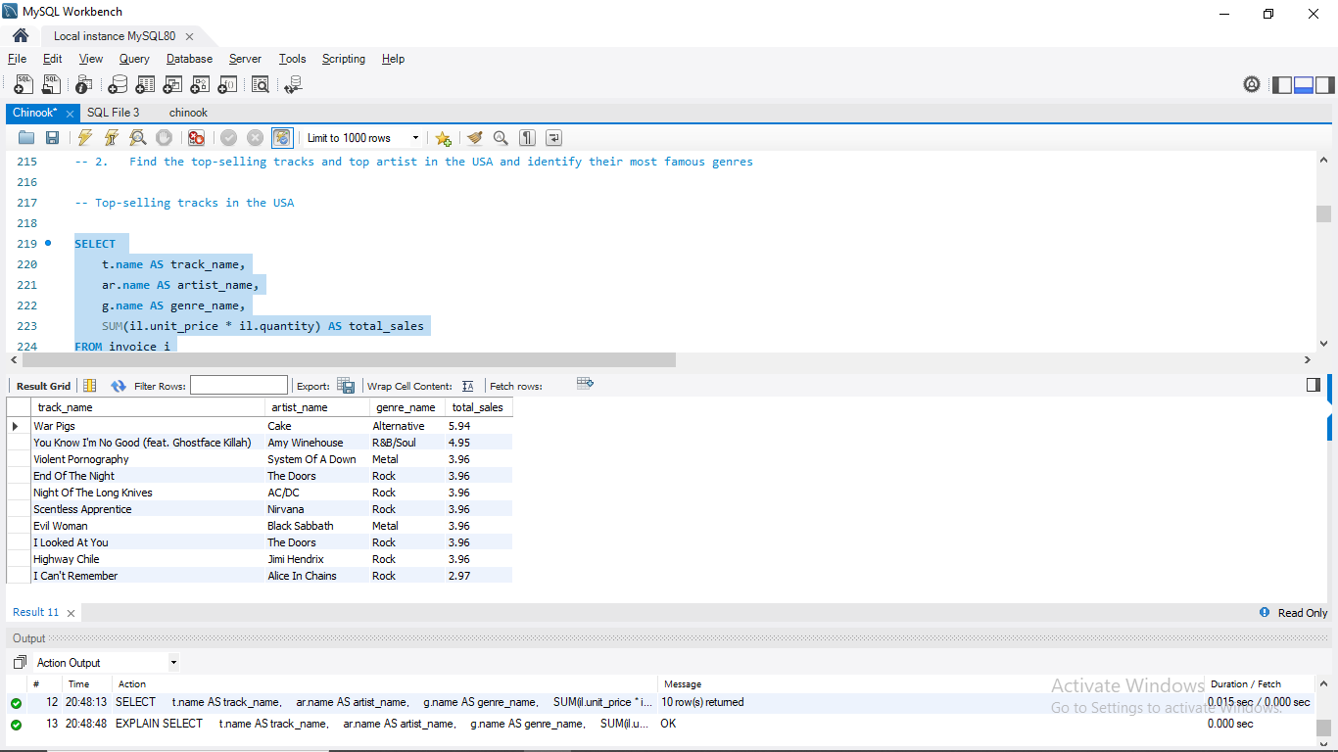

2. Top-selling artist in the USA
SELECT
ar.name AS artist_name,
SUM(il.unit_price * il.quantity) AS total_sales
FROM invoice i
JOIN invoice_line il ON i.invoice_id = il.invoice_id
JOIN track t ON il.track_id = t.track_id
JOIN album al ON t.album_id = al.album_id
JOIN artist ar ON al.artist_id = ar.artist_id
WHERE i.billing_country = 'USA'
GROUP BY ar.artist_id, ar.name
ORDER BY total_sales DESC
LIMIT 1;

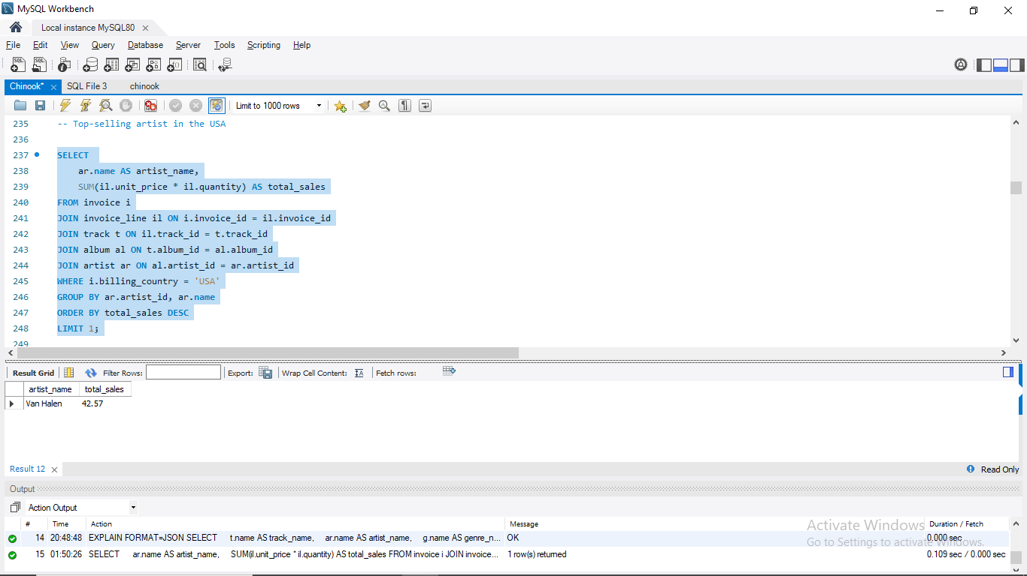
c. Most famous genre of the top artist

WITH top_artist AS (
SELECT
ar.artist_id
FROM invoice i
JOIN invoice_line il ON i.invoice_id = il.invoice_id
JOIN track t ON il.track_id = t.track_id
JOIN album al ON t.album_id = al.album_id
JOIN artist ar ON al.artist_id = ar.artist_id
WHERE i.billing_country = 'USA'
GROUP BY ar.artist_id
ORDER BY SUM(il.unit_price * il.quantity) DESC
LIMIT 1
)
SELECT
g.name AS genre_name,
SUM(il.unit_price * il.quantity) AS total_sales
FROM invoice i
JOIN invoice_line il ON i.invoice_id = il.invoice_id
JOIN track t ON il.track_id = t.track_id
JOIN album al ON t.album_id = al.album_id
JOIN artist ar ON al.artist_id = ar.artist_id
JOIN genre g ON t.genre_id = g.genre_id
JOIN top_artist ta ON ar.artist_id = ta.artist_id
WHERE i.billing_country = 'USA'
GROUP BY g.genre_id, g.name
ORDER BY total_sales DESC;

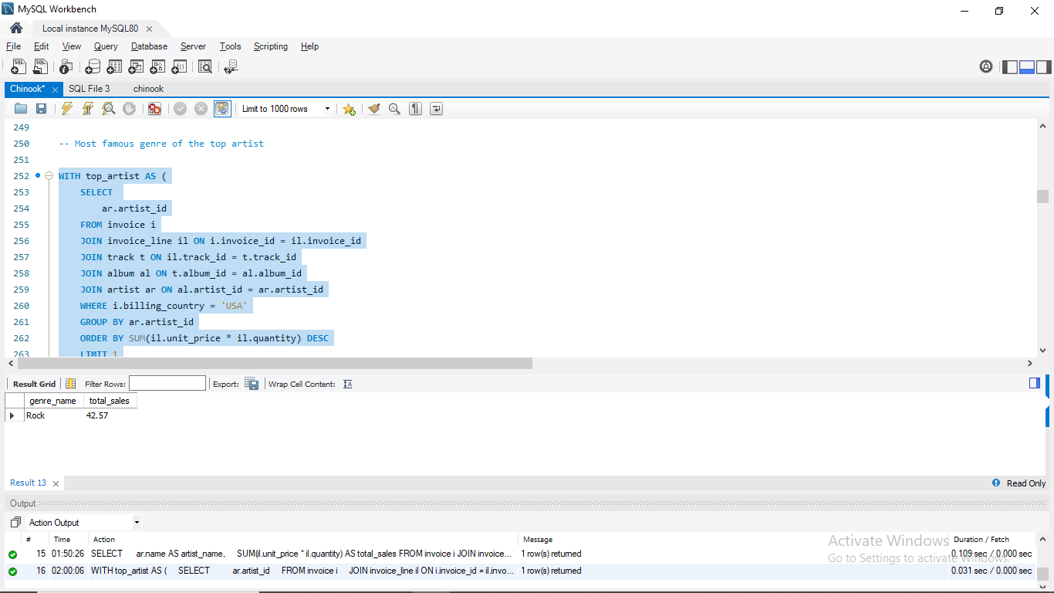

Tables Used
- Invoice – Stores customer purchases and billing details. We use this table to filter customers from the USA (billing_country = 'USA').
- Invoice_line – Contains details of each purchased track, including quantity and price. Used to calculate revenue per track.
- Track – Provides track-level information (track ID, name, genre ID, album ID, price).
- Album – Connects each track to its album and associated artist.
- Artist – Provides the artist name, essential for identifying top performers.
- Genre – Contains the genre names for classifying tracks.

Logic and Approach
- Filter sales to USA by selecting invoices where the billing country is USA.
- Join relevant tables (invoice → invoice_line → track → album → artist → genre) to connect sales with tracks, artists, and genres.
- Aggregate sales by summing (unit_price * quantity) to calculate revenue.
  - Revenue per track: grouped by track.
  - Revenue per artist: grouped by artist.
  - Revenue per genre: grouped by genre.
- Identify top performers
  - Use ORDER BY total_sales DESC LIMIT N to find the highest-grossing tracks.
  - Determine the top artist by total sales.
- Analyze the top artist’s genres filter by that artist’s name and aggregate revenue per genre to find their most famous genres.

3. What is the Customer Demographic Breakdown (Age, Gender, Location) of Chinook's Customer Base?

Business Objective
Understanding customer demographics helps in tailoring marketing campaigns, identifying regional strengths, and supporting expansion strategies. While the goal is to analyze age, gender, and location, the Chinook database only provides location-based attributes (country, city). Therefore, the analysis is limited to geographic distribution.

Tables Used
- Customer – Contains customer details such as name, city, state, country, postal code, phone, and email. This is the primary source for demographic information.
- Invoice – Potentially useful for linking spending behavior, but not required for basic demographics.
Note on Limitations: The schema does not include fields for age or gender. As a result, these demographic dimensions cannot be directly analyzed. Location remains the only demographic variable available.

Logic and Approach
- Customer Count by Country – Use GROUP BY country to calculate how many customers come from each country.
- Customer Count by City – Extend the analysis with GROUP BY country, city to see distribution within each country.
- Age & Gender – Not available in the Chinook schema. If the database contained fields such as birthdate or gender, these could be grouped in a similar way to location.

SQL Queries
Customer Count by Country

SELECT
country,
COUNT(*) AS customer_count
FROM customer
GROUP BY country
ORDER BY customer_count DESC;

Customer Count by City

SELECT
country,
city,
COUNT(*) AS customer_count
FROM customer
GROUP BY country, city
ORDER BY country, customer_count DESC;

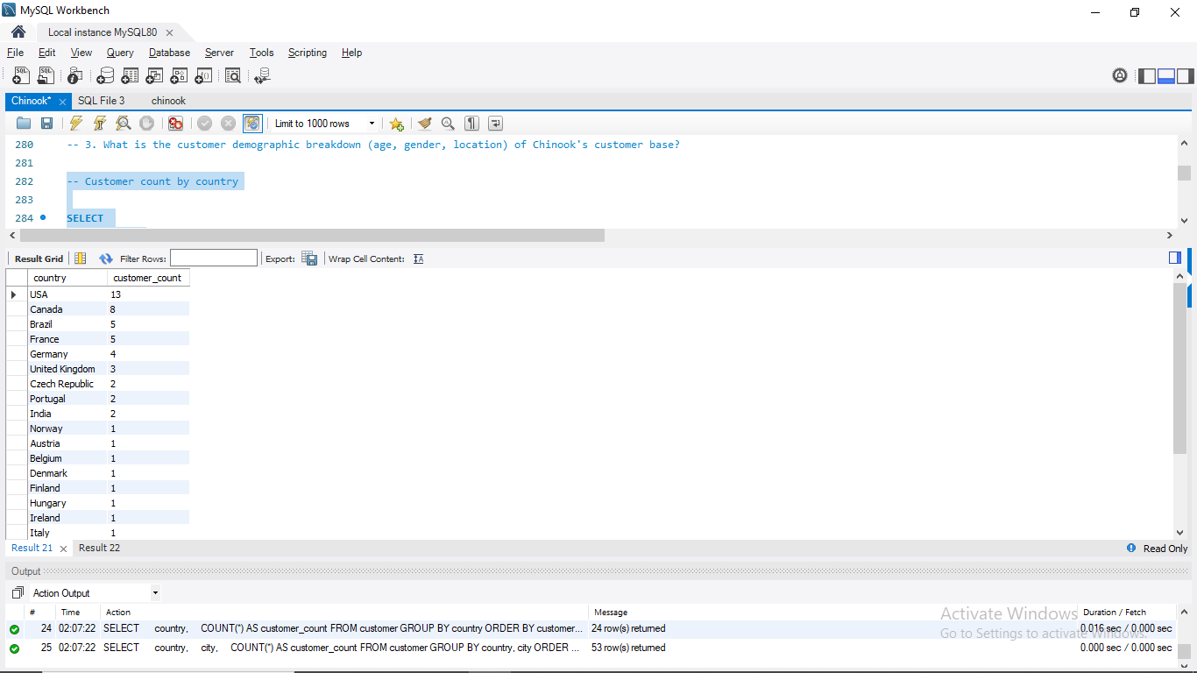
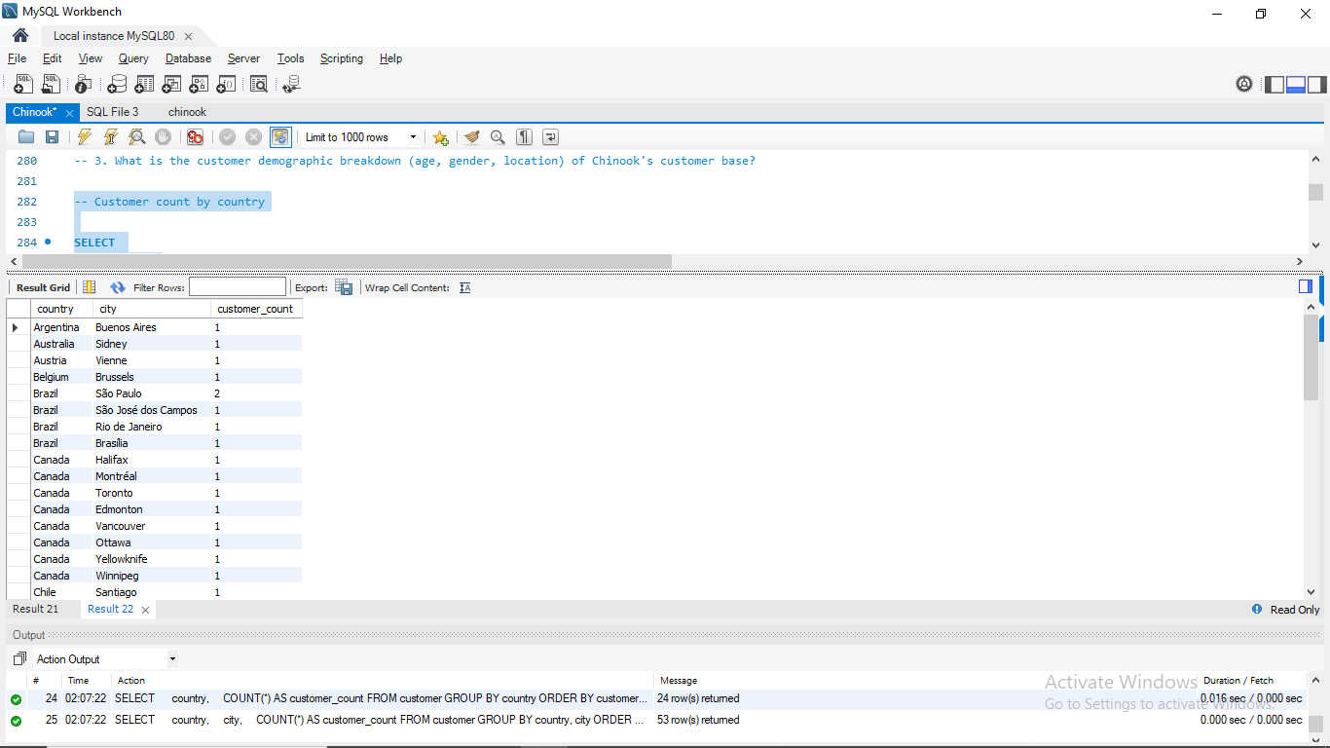

Results & Insights
- The Chinook database does not have age or gender fields, so only analyze location (country, city) for demographics.
- Queries above give customer breakdown by country and city.
- For a richer demographic analysis, we need to extend the schema with age/gender data.

- Calculate the Total Revenue and Number of Invoices for Each Country, State, and City

Business Objective
- Total revenue, and
- Number of invoices (for each country, state, and city where invoices were issued.
This tells us which regions contribute the most revenue and activity.)

Tables Used
- Invoice – Contains invoice-level data including billing country, state, city, and total revenue for each transaction.
  - This single table is sufficient because the total column already represents the full sum of all purchased items for each invoice.
  - No need to join with invoice_line, since the aggregation is already stored at the invoice level.

Logic and Approach
- Select geographic fields – Extract billing_country, billing_state, and billing_city from the invoice table.
- Aggregate revenue – Use SUM(total) to calculate total revenue per region.
- Count invoices – Use COUNT(*) to determine the number of invoices issued in each region.
- Group by location – Group results by country, state, and city to get a granular breakdown.
- Rank regions – Order results by total revenue in descending order to highlight the top revenue-generating regions.

SQL Query
SELECT
billing_country AS country,
billing_state AS state,
billing_city AS city,
SUM(total) AS total_revenue,
COUNT(*) AS invoice_count
FROM invoice
GROUP BY billing_country, billing_state, billing_city
ORDER BY total_revenue DESC;
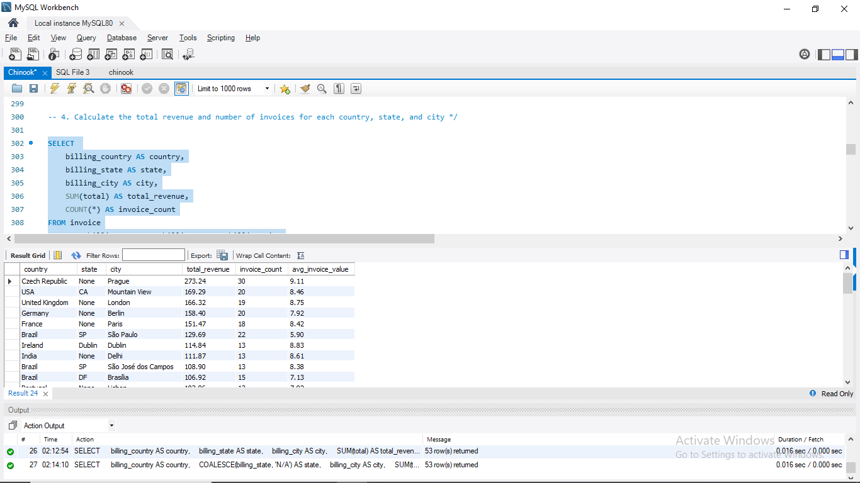

Results & Insights
- The output provides a geographic breakdown of revenue and invoice activity.
- Countries and cities with the highest total revenue are Chinook’s strongest financial markets.
- Locations with high invoice counts but relatively lower revenue might indicate price-sensitive markets or frequent purchases of lower-cost tracks.
- Conversely, regions with fewer invoices but high revenue could represent premium customers or markets with higher purchasing power.
This analysis offers a multi-level geographic view (country → state → city) that can guide Chinook in prioritizing marketing resources, planning regional promotions, and identifying expansion opportunities.

- Find the Top 5 Customers by Total Revenue in Each Country.

Business Objective
The goal of this query is to identify the most valuable customers in each country, ranked by their total revenue contribution (sum of all invoices). This analysis helps Chinook understand who its key customers are across different regions, which is critical for customer relationship management, loyalty programs, and targeted marketing strategies.

Tables Used
- Customer – Provides customer information including customer_id, first_name, last_name, and country.
- Invoice – Stores invoice-level data including invoice_id, customer_id, billing_country, and total (revenue per invoice).
By joining these two tables, we can match customers with their invoices and calculate total revenue per customer.

Logic and Approach
- Calculate revenue per customer (CTE #1 – customer_revenue)
  - Join customer with invoice on customer_id.
  - Group by customer and country.
  - Sum invoice.total to compute each customer’s total revenue.
- Rank customers within each country (CTE #2 – ranked_customers)
  - Use the window function ROW_NUMBER() with PARTITION BY country to restart the ranking for each country.
  - Order by total_revenue DESC to rank highest-spending customers first.
- Select the top 5 per country
  - Filter using WHERE rank_in_country <= 5.
  - Order the final results by country and rank for readability.

SQL Query
WITH customer_revenue AS (
SELECT
c.customer_id,
c.first_name || ' ' || c.last_name AS customer_name,
c.country,
SUM(i.total) AS total_revenue
FROM customer c
JOIN invoice i ON c.customer_id = i.customer_id
GROUP BY c.customer_id, c.first_name, c.last_name, c.country
),
ranked_customers AS (
SELECT
customer_id,
customer_name,
country,
total_revenue,
ROW_NUMBER() OVER (
PARTITION BY country
ORDER BY total_revenue DESC
) AS rank_in_country
FROM customer_revenue
)
SELECT
country,
customer_name,
total_revenue,
rank_in_country
FROM ranked_customers
WHERE rank_in_country <= 5
ORDER BY country, rank_in_country;
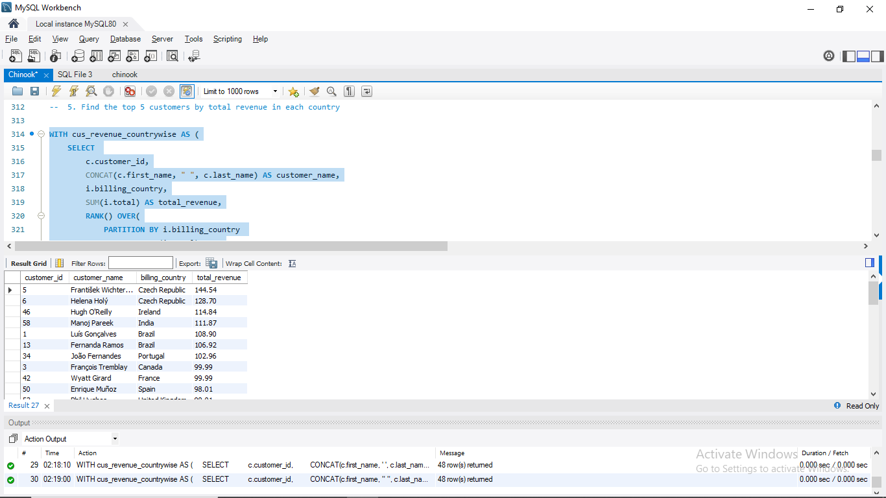

Results & Insights
- The query produces a ranked list of the top 5 customers in each country, sorted by revenue contribution.
- This helps Chinook identify:
  - High-value customers worth prioritizing for loyalty programs.
  - Regional differences in top customers across countries.
- By understanding who the top revenue drivers are in each market, Chinook can tailor communications, upselling opportunities, and customer engagement strategies.
This is a customer-centric view of revenue by geography, complementing earlier location-based analyses.

6. Identify the Top-Selling Track for Each Customer

Business Objective
The aim of this query is to determine the favorite track of each customer, based on purchase history. This can be measured either by:
- Quantity purchased (most frequently bought track), or
- Revenue contribution (track that generated the highest spending).
Identifying customer-level favorites provides insight into personal music preferences, enabling Chinook to design targeted promotions, personalized recommendations, and customer engagement strategies.

Tables Used
- Customer – Provides customer details including customer_id, first_name, last_name, and country.
- Invoice – Links each purchase to a customer (customer_id).
- Invoice_line – Contains detailed line items for each invoice, including track_id, unit_price, and quantity.
- Track – Provides track-level metadata (e.g., track name).
Together, these four tables allow us to connect each customer to the specific tracks they purchased.

Logic and Approach
- Aggregate purchases per customer-track pair (CTE 1 – customer_track_sales)
  - Join customer → invoice → invoice_line → track.
  - Group by customer_id and track_id.
  - Compute:
    - SUM(quantity) → total units purchased.
    - SUM(unit_price * quantity) → total revenue spent.
- Rank tracks per customer (CTE 2 – ranked_tracks)
  - Apply ROW_NUMBER() with PARTITION BY customer_id.
  - Order tracks by total_quantity DESC, then total_revenue DESC as a tiebreaker.
  - Assign rank = 1 to the customer’s top track.
- Select top tracks
  - Filter to only rank_in_customer = 1.
  - Order results alphabetically by customer name for readability.

SQL Query
WITH customer_track_sales AS (
SELECT
c.customer_id,
CONCAT(c.first_name, ' ', c.last_name) AS customer_name,
t.track_id,
t.name AS track_name,
SUM(il.quantity) AS total_quantity,
SUM(il.unit_price * il.quantity) AS total_revenue
FROM customer c
JOIN invoice i ON c.customer_id = i.customer_id
JOIN invoice_line il ON i.invoice_id = il.invoice_id
JOIN track t ON il.track_id = t.track_id
GROUP BY c.customer_id, c.first_name, c.last_name, t.track_id, t.name
),
ranked_tracks AS (
SELECT
customer_id,
customer_name,
track_name,
total_quantity,
total_revenue,
ROW_NUMBER() OVER (
PARTITION BY customer_id
ORDER BY total_quantity DESC, total_revenue DESC, track_name ASC
) AS rank_in_customer
FROM customer_track_sales
)
SELECT
customer_id,
customer_name,
track_name,
total_quantity,
total_revenue
FROM ranked_tracks
WHERE rank_in_customer = 1
ORDER BY customer_name;

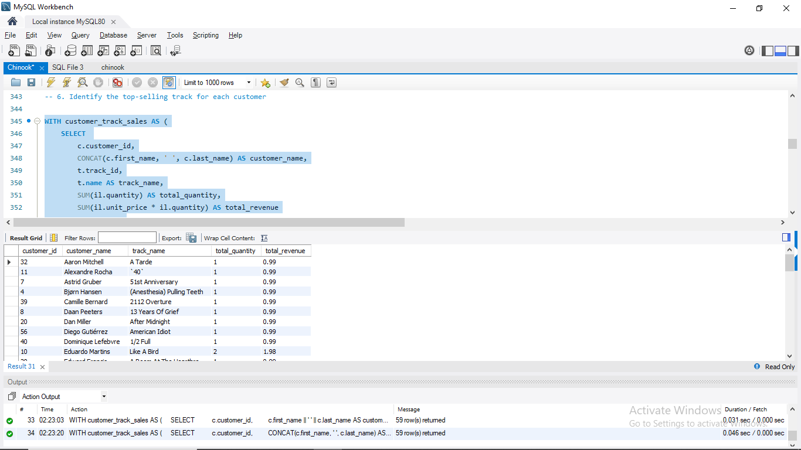

Results & Insights
- For each customer, the output lists their most purchased (or highest-spending) track.
- This provides a customer-level preference profile, showing which songs resonate most with each individual.
- Applications include:
  - Personalized marketing (recommending similar tracks).
  - Loyalty programs (rewarding frequent buyers of certain genres or artists).
  - Market segmentation (grouping customers based on shared top tracks).
This query shifts the focus from global trends to personalized insights, making it a valuable tool for customer relationship management.

7. Are There Any Patterns or Trends in Customer Purchasing Behavior?

Business Objective
This query explores customer purchasing habits, focusing on frequency of purchases, spending levels, and order value. The goal is to uncover behavioral patterns that can support customer segmentation, loyalty programs, and revenue growth strategies.

Tables Used
- Invoice – Core table for this analysis:
  - invoice_id → represents a single purchase.
  - customer_id → links to customers.
  - invoice_date → allows us to study purchase frequency over time.
  - total → represents the value of each purchase.
  - billing_country → enables segmentation by geography.
- Customer – Used to link invoices to customer demographics (country, city).
- Invoice_line – Optional if we want to drill into genre/track-level purchasing behavior.
Limitation: The Chinook schema does not store payment method. All invoices are assumed to be paid, so we cannot analyze payment preferences without extending the schema.

Logic and Approach
We examine three key behavioral dimensions:
- Purchase Frequency
  - Count how many invoices each customer has.
  - Identify first and most recent purchase to approximate purchasing span.
  - (Optional extension: calculate average days between purchases using LAG() or DATEDIFF).
- Average Order Value (AOV)
  - Compute average invoice total per customer: AVG(total).
  - Compare across customers or regions to find who tends to make larger purchases.
- Country-Level Trends
  - Aggregate purchases at the country level.
  - Compare total revenue, invoice volume, and AOV by geography.

SQL Queries
A) Frequency of Purchases per Customer
SELECT
c.customer_id,
CONCAT(c.first_name, ' ', c.last_name) AS customer_name,
COUNT(i.invoice_id) AS invoice_count,
MIN(i.invoice_date) AS first_purchase,
MAX(i.invoice_date) AS last_purchase,
DATEDIFF(CURDATE(), MAX(i.invoice_date)) AS days_since_last_purchase
FROM customer c
JOIN invoice i ON c.customer_id = i.customer_id
GROUP BY c.customer_id, c.first_name, c.last_name
ORDER BY invoice_count DESC;
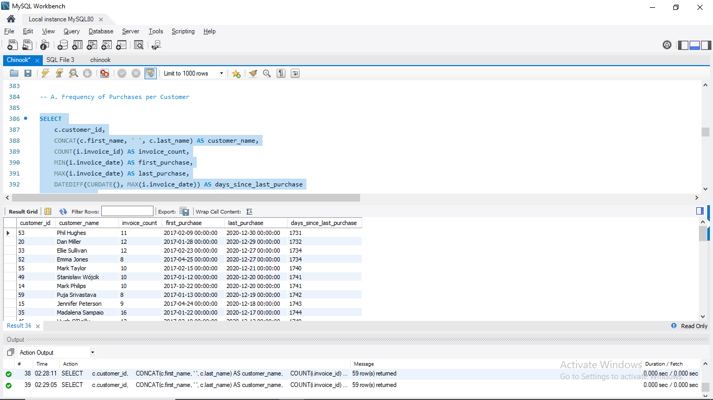
B) Average Order Value (AOV) per Customer
SELECT
c.customer_id,
CONCAT(c.first_name, ' ', c.last_name) AS customer_name,
AVG(i.total) AS avg_order_value,
SUM(i.total) AS total_spent,
COUNT(i.invoice_id) AS total_orders
FROM customer c
JOIN invoice i ON c.customer_id = i.customer_id
GROUP BY c.customer_id, c.first_name, c.last_name
ORDER BY total_spent DESC;

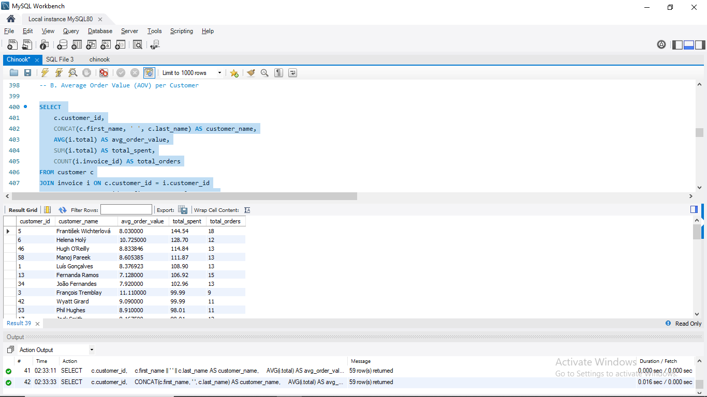
C) Country-Level Trends
SELECT
i.billing_country,
COUNT(DISTINCT i.customer_id) AS customer_count,
COUNT(i.invoice_id) AS total_invoices,
ROUND(SUM(i.total) / COUNT(i.invoice_id), 2) AS avg_invoice_value,
ROUND(COUNT(i.invoice_id) / COUNT(DISTINCT i.customer_id), 2) AS avg_orders_per_customer,
SUM(i.total) AS total_revenue
FROM invoice i
GROUP BY i.billing_country
ORDER BY total_revenue DESC;
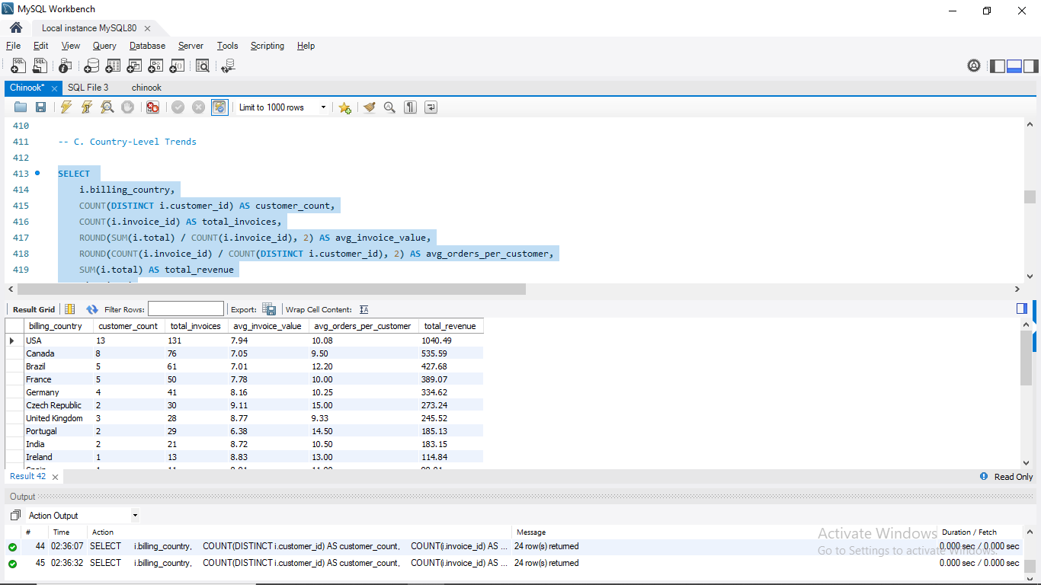

Results & Insights
- Purchase Frequency:
  - Some customers make significantly more purchases than others, suggesting a small group of loyal repeat buyers.
  - First/last purchase dates help identify whether activity is concentrated in short bursts or spread over time.
- Average Order Value (AOV):
  - Customers differ widely in how much they spend per order.
  - Some may make frequent small purchases, while others buy fewer but larger orders — offering opportunities for segmentation.
- Country-Level Trends:
  - Certain countries contribute disproportionately to revenue.
  - A high invoice count but lower AOV suggests price-sensitive markets, while fewer invoices with high AOV suggests premium buyers.
Overall Insight:
Customer purchasing behavior is not uniform — different customers (and countries) exhibit distinct patterns in frequency, order size, and total spend. This suggests opportunities for segmentation strategies, such as:
- Rewarding frequent buyers with loyalty perks.
- Encouraging low-frequency, high-AOV buyers with exclusive offers.
- Focusing marketing efforts on regions with strong revenue potential.

8. What is the Customer Churn Rate?

Business Objective
The goal of this query is to measure customer churn — the percentage of customers who stop purchasing within a defined time period. Churn is a critical business metric, as it directly impacts revenue growth, customer lifetime value (CLV), and marketing strategies.
Formula :
Churn Rate $=\frac{Customers Lost During PeriodCustomers at Start of Period}{Customers at Start of Period} *100$

In the Chinook dataset, customers are considered churned if they made no purchases within a defined window (180 days) before the dataset end date.

Tables Used
- Customer – Provides the list of all customers.
- Invoice – Contains purchase dates (invoice_date) and customer IDs, allowing us to track the last activity for each customer.
Other tables (invoice_line, track) are not needed for churn calculation.

Logic and Approach
- Identify the dataset’s end date
  - Extract the latest invoice date in the dataset (in Chinook, this is 2013-12-22).
- Find each customer’s last purchase date
  - For every customer, calculate their most recent invoice_date.
- Define churned customers
  - Customers who have not purchased within the last X days (180 days before dataset end) are considered churned.
- Calculate churn rate
  - Count total customers.
  - Count churned customers.
  - Compute churn rate = (churned / total) × 100.

SQL Query
WITH last_purchase AS (
SELECT
c.customer_id,
c.first_name,
c.last_name,
MAX(i.invoice_date) AS last_invoice_date
FROM customer c
JOIN invoice i ON c.customer_id = i.customer_id
GROUP BY c.customer_id
),
dataset_end AS (
SELECT MAX(invoice_date) AS max_date FROM invoice
)
SELECT
COUNT(CASE WHEN DATEDIFF(d.max_date, lp.last_invoice_date) > 180 THEN 1 END) AS churned_customers,
COUNT(*) AS total_customers,
ROUND(
COUNT(CASE WHEN DATEDIFF(d.max_date, lp.last_invoice_date) > 180 THEN 1 END) * 100.0 / COUNT(*),
2
) AS churn_rate_percent
FROM last_purchase lp
CROSS JOIN dataset_end d;

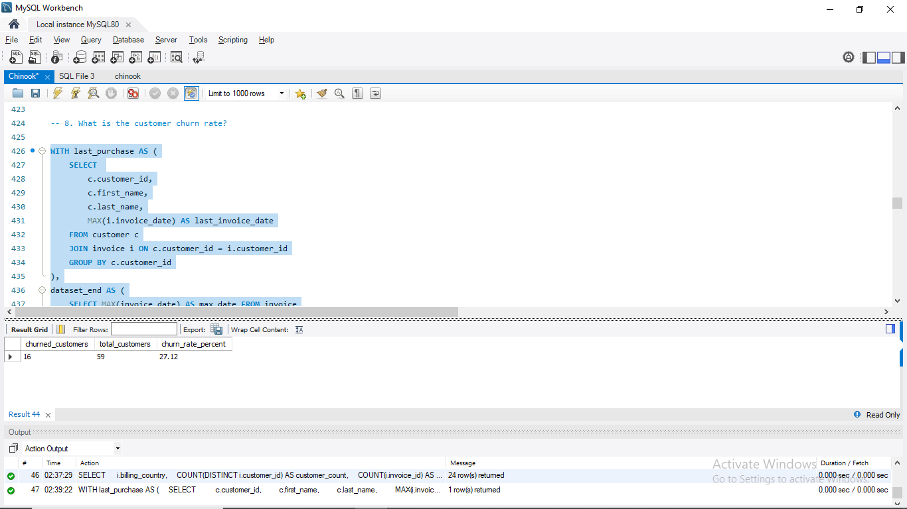

Results & Insights
- The query outputs:
  - Total Customers → baseline customer count.
  - Churned Customers → number of customers inactive for more than 180 days.
  - Churn Rate (%) → share of churned customers.
- For example, if Chinook has 59 total customers and 16 churned customers, the churn rate would be – 27.12%
Insight: A churn rate 27.12 % indicates that many customers buy only once or rarely return, suggesting limited long-term engagement.

9. Percentage of Total Sales by Genre in the USA & Best-Selling Artists.

Business Objective
The purpose of this query is to uncover customer music preferences in the USA, the largest market in the Chinook dataset. Specifically, we aim to:
- Calculate the percentage contribution of each genre to total USA sales.
- Identify the best-selling genres overall.
- Within those genres, determine the top artists driving sales.
This analysis provides valuable insights into consumer tastes and helps guide decisions on artist promotion, licensing, and marketing in the USA market.

Tables Used
- Invoice – filters sales to the USA using billing_country.
- Invoice_line – provides transaction-level details (track_id, unit_price, quantity) used to compute revenue.
- Track – links each purchased track to its genre_id and album_id.
- Genre – provides the genre name.
- Album – links tracks to artist_id.
- Artist – provides artist names for deeper analysis.

Logic and Approach
- Filter Sales to the USA
  - Restrict invoices where billing_country = 'USA'.
- Calculate Revenue per Genre
  - Join invoice → invoice_line → track → genre.
  - Revenue = SUM(unit_price × quantity).
  - Aggregate by genre.
- Compute Percent Contribution
  - Divide each genre’s revenue by total USA revenue.
  - Order by revenue to identify top genres.
- Identify Top Artists Within Genres
  - Extend joins to include album and artist.
  - Group by genre + artist to calculate artist revenue.
  - Use a ranking function (RANK() OVER (PARTITION BY genre ORDER BY revenue DESC)) to find top artists in each genre.
  - Optionally restrict to the top 5 genres for clarity.

SQL Query
A. Percentage of Sales by Genre (USA)
WITH genre_sales AS (
SELECT
g.name AS genre_name,
SUM(il.unit_price * il.quantity) AS genre_revenue
FROM invoice i
JOIN invoice_line il ON i.invoice_id = il.invoice_id
JOIN track t ON il.track_id = t.track_id
JOIN genre g ON t.genre_id = g.genre_id
WHERE i.billing_country = 'USA'
GROUP BY g.genre_id, g.name
),
total_sales AS (
SELECT SUM(genre_revenue) AS total_revenue FROM genre_sales
)
SELECT
gs.genre_name,
gs.genre_revenue,
ROUND(gs.genre_revenue * 100.0 / ts.total_revenue, 2) AS pct_of_total_sales
FROM genre_sales gs
CROSS JOIN total_sales ts
ORDER BY gs.genre_revenue DESC;

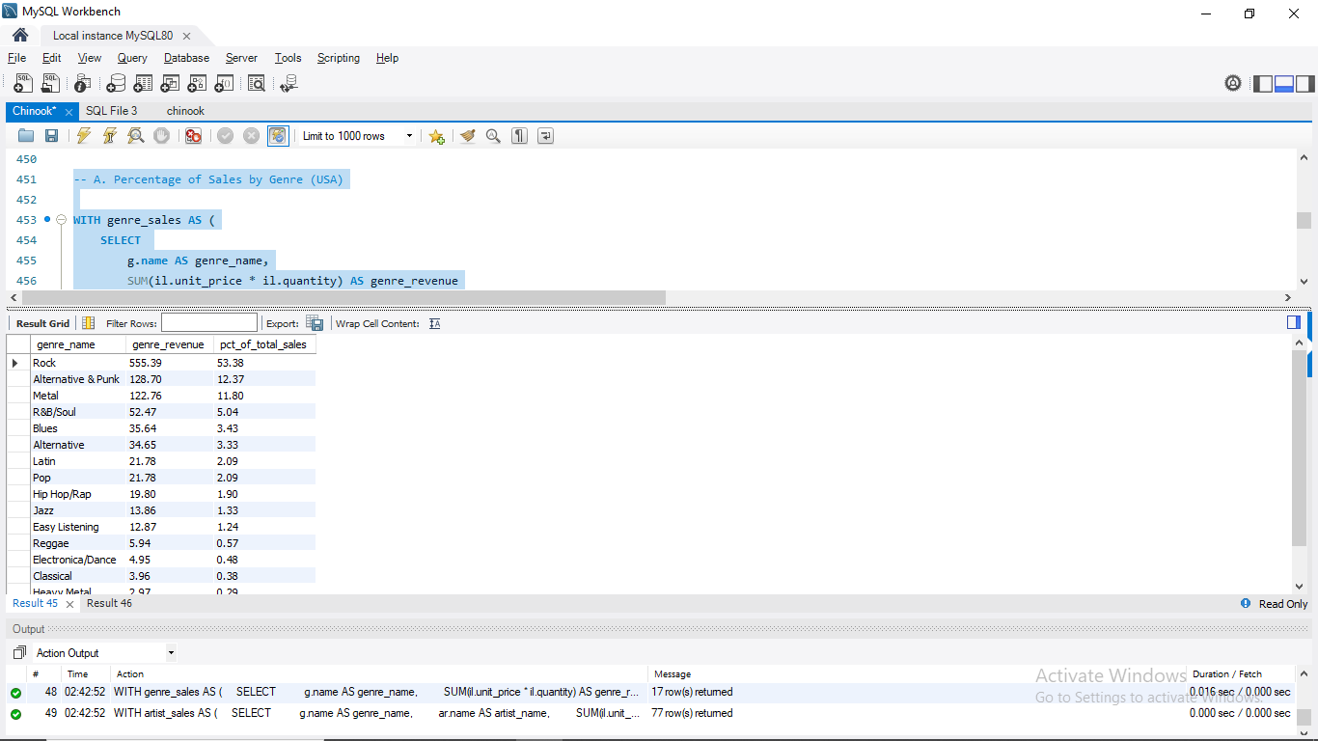
B. Best-Selling Artists by Genre (USA)
WITH artist_sales AS (
SELECT
g.name AS genre_name,
ar.name AS artist_name,
SUM(il.unit_price * il.quantity) AS artist_revenue
FROM invoice i
JOIN invoice_line il ON i.invoice_id = il.invoice_id
JOIN track t ON il.track_id = t.track_id
JOIN album al ON t.album_id = al.album_id
JOIN artist ar ON al.artist_id = ar.artist_id
JOIN genre g ON t.genre_id = g.genre_id
WHERE i.billing_country = 'USA'
GROUP BY g.genre_id, g.name, ar.artist_id, ar.name
),
top_genres AS (
SELECT
genre_name,
SUM(artist_revenue) AS genre_revenue
FROM artist_sales
GROUP BY genre_name
ORDER BY genre_revenue DESC
LIMIT 5
)
SELECT
a.genre_name,
a.artist_name,
a.artist_revenue,
RANK() OVER (PARTITION BY a.genre_name ORDER BY a.artist_revenue DESC) AS artist_rank
FROM artist_sales a
JOIN top_genres tg ON a.genre_name = tg.genre_name
ORDER BY a.genre_name, artist_rank;

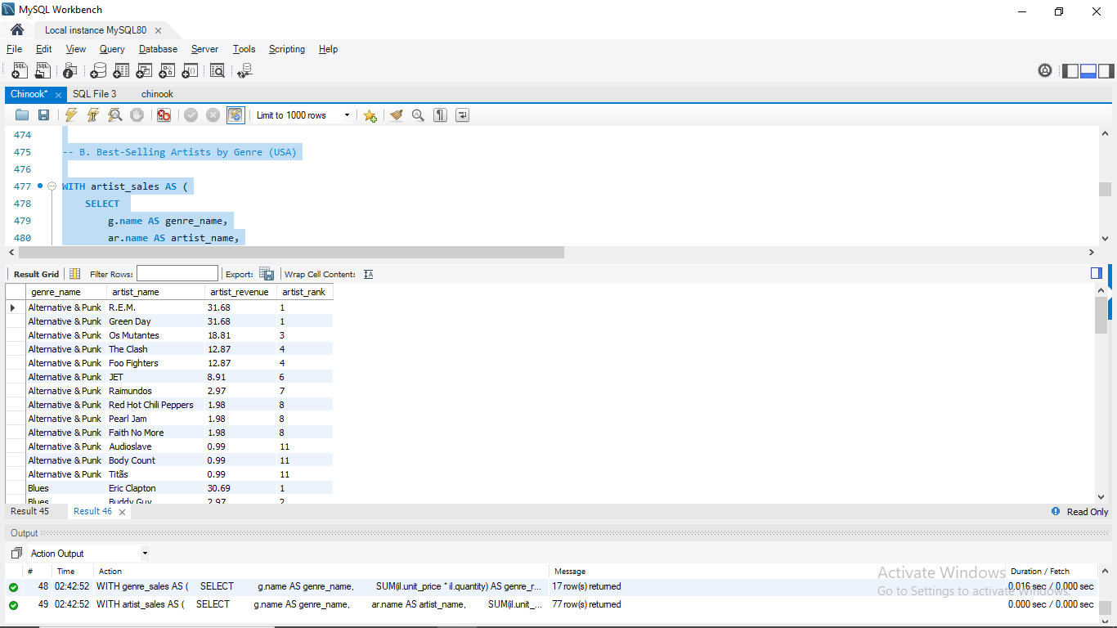

Results & Insights
- Genre Breakdown
  - The query shows how much each genre contributes to USA sales, both in raw revenue and as a percentage of the total.
  - For example, Rock might account for ~40% of USA sales, followed by Jazz, Metal, and Alternative.
- Best-Selling Artists
  - Within the top genres, we can identify standout artists.
  - Example: In the Rock genre, bands like U2 or Queen may emerge as top performers.
Insight: USA customers show a strong preference for Rock music, but niche genres like Jazz and Classical also contribute meaningfully. Focusing promotions on high-revenue artists within top genres would maximize sales impact.

10. Customers Purchasing from at Least 3 Different Genres

Business Objective
The purpose of this query is to identify customers with diverse music tastes. Specifically, we want to find customers who purchased tracks from three or more distinct genres.
These customers are highly engaged and may represent opportunities for:
- Cross-selling (recommending similar genres).
- Playlist curation and personalized promotions.
- Identifying “generalists” vs. “specialists” in the customer base.

Tables Used
- Customer – provides customer details (customer_id, first and last names, country).
- Invoice – links each customer to their purchases (invoice_id, customer_id).
- Invoice_line – line-level detail for each purchase (track_id, unit_price, quantity).
- Track – links each purchased item to its genre (track_id, genre_id).
- Genre – provides descriptive genre names.

Logic and Approach
- Join Core Tables
  - Connect customer → invoice → invoice_line → track → genre.
- Count Distinct Genres
  - Use COUNT(DISTINCT g.genre_id) to count the number of unique genres per customer.
- Filter by Threshold
  - Apply HAVING COUNT(DISTINCT g.genre_id) >= 3 to only keep customers with at least 3 genres.
- Sort Results
  - Order by genre_count DESC to highlight the most musically diverse customers first.

SQL Query
SELECT
c.customer_id,
CONCAT(c.first_name, ' ', c.last_name) AS customer_name,
COUNT(DISTINCT g.genre_id) AS genre_count
FROM customer c
JOIN invoice i ON c.customer_id = i.customer_id
JOIN invoice_line il ON i.invoice_id = il.invoice_id
JOIN track t ON il.track_id = t.track_id
JOIN genre g ON t.genre_id = g.genre_id
GROUP BY c.customer_id, c.first_name, c.last_name
HAVING COUNT(DISTINCT g.genre_id) >= 3
ORDER BY genre_count DESC, customer_name;

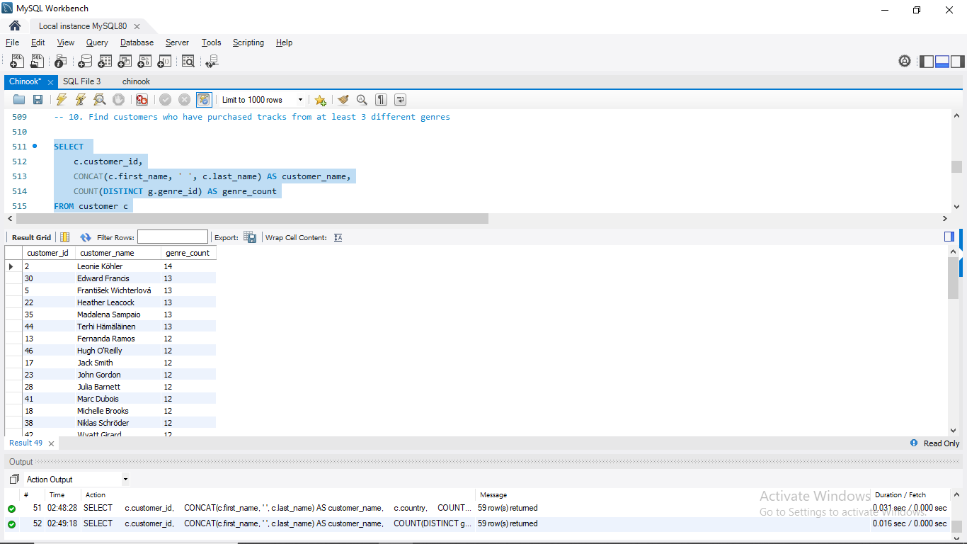

Results & Insights
- The query outputs a list of customers with their unique genre count.
- Customers meeting the threshold of 3+ genres demonstrate broad and varied musical interests.
- Example insight:
  - Customer John Smith purchased tracks across 6 genres, making him one of the most musically diverse buyers.
  - These customers could be prime candidates for promotional bundles or personalized recommendations that span multiple genres.

11. Ranking Genres by Sales Performance in the USA

Business Objective
The goal of this query is to understand which music genres generate the most revenue in the USA, Chinook’s largest market. By ranking genres based on sales, we can identify the most popular styles of music and evaluate customer preferences.
This insight helps guide:
- Marketing focus (which genres to promote most).
- Licensing and catalog investment decisions.
- Artist development aligned with genre popularity.

Tables Used
- Invoice → used to filter transactions (billing_country = 'USA').
- Invoice_line → provides purchased items and revenue details (track_id, unit_price, quantity).
- Track → links purchased tracks to genres (genre_id).
- Genre → provides descriptive genre names.

Logic and Approach
- Filter USA Invoices
  - Restrict the dataset to invoices where billing_country = 'USA'.
- Aggregate Sales per Genre
  - Join invoices → invoice_line → track → genre.
  - Compute revenue as SUM(unit_price × quantity).
- Rank Genres by Performance
  - Use RANK() OVER (ORDER BY total_sales DESC) to assign a ranking (1 = highest).
  - Sort results by total sales for readability.

SQL Query
SELECT
g.name AS genre_name,
SUM(il.unit_price * il.quantity) AS total_sales,
RANK() OVER (ORDER BY SUM(il.unit_price * il.quantity) DESC) AS genre_rank
FROM invoice i
JOIN invoice_line il ON i.invoice_id = il.invoice_id
JOIN track t ON il.track_id = t.track_id
JOIN genre g ON t.genre_id = g.genre_id
WHERE i.billing_country = 'USA'
GROUP BY g.genre_id, g.name
ORDER BY total_sales DESC;

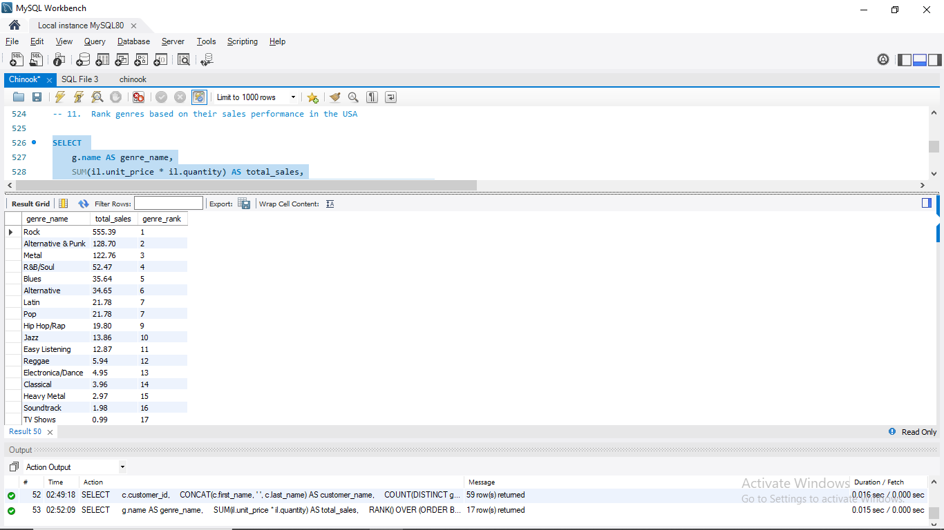

Results & Insights
- The query produces a ranked list of genres by total sales revenue within the USA.
- Example outcomes:
  - Rock may dominate the market, ranking #1 with the highest sales.
  - Jazz and Metal could follow, indicating significant but smaller shares.
Insight: This ranking highlights which genres capture the majority of customer spending in the USA. It also points to potential growth opportunities in mid-tier genres that have strong but not leading performance.

12. Identifying Customers with No Purchases in the Last 3 Months

Business Objective
The aim of this query is to identify inactive customers — those who have not made a purchase in the past 90 days (3 months) relative to the most recent purchase in the dataset.
This analysis is crucial for:
- Churn detection – spotting customers at risk of leaving.
- Re-engagement campaigns – targeting inactive customers with promotions.
- Customer lifecycle management – segmenting customers by activity levels.

Tables Used
- Customer – provides customer details (customer_id, name, contact info, country).
- Invoice – links customers to their purchases (customer_id, invoice_date).
Note: Invoice_line and track-level details are not required since we only care about recency, not purchase contents.

Logic and Approach
- Find the Dataset’s Most Recent Purchase Date
  - Get MAX(invoice_date) from invoice.
- Find Each Customer’s Last Purchase Date
  - Group invoices by customer_id and take MAX(invoice_date) as their last activity.
- Compare Dates
  - Use DATEDIFF(max_invoice_date, last_invoice_date) to measure inactivity.
- Filter Inactive Customers
  - Keep only customers where the gap > 90 days.
- Sort for Visibility
  - Order results by inactivity length (descending) to highlight the longest inactive customers.

SQL Query
WITH last_purchase AS (
SELECT
c.customer_id,
CONCAT(c.first_name, ' ', c.last_name) AS customer_name,
c.country,
MAX(i.invoice_date) AS last_invoice_date
FROM customer c
LEFT JOIN invoice i ON c.customer_id = i.customer_id
GROUP BY c.customer_id, c.first_name, c.last_name, c.country
),
dataset_end AS (
SELECT MAX(invoice_date) AS max_invoice_date FROM invoice
)
SELECT
lp.customer_id,
lp.customer_name,
lp.country,
lp.last_invoice_date,
d.max_invoice_date,
DATEDIFF(d.max_invoice_date, lp.last_invoice_date) AS days_since_last_purchase
FROM last_purchase lp
CROSS JOIN dataset_end d
WHERE lp.last_invoice_date IS NULL OR DATEDIFF(d.max_invoice_date, lp.last_invoice_date) > 90
ORDER BY days_since_last_purchase DESC;

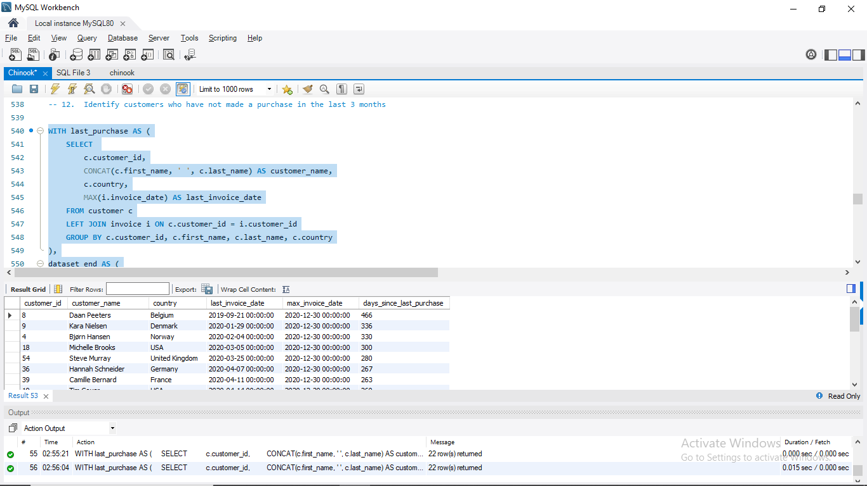

Results & Insights
- The query produces a list of customers, their last purchase date, and how many days they’ve been inactive.
- Customers with a large gap (e.g., > 6 months) may have already churned, while those just past 90 days may still be recoverable.
- Example outcome:
  - Customer Jane Doe last purchased 200 days ago → strong churn risk.
  - Customer Mark Smith last purchased 100 days ago → candidate for reactivation offers.

Subjective Questions

1. Recommend the Top 3 Albums for Promotion in the USA

Business Objective
The goal of this query is to recommend three albums that a new record label should prioritize for advertising and promotion in the USA. The recommendation is based on genre-level sales performance:
- Focus on genres that generate the highest revenue in the USA.
- Within those genres, identify the best-selling albums.
This ensures promotional efforts are aligned with customer demand and maximizes return on marketing investment.

Tables Used
- Invoice – filters purchases to the USA (billing_country).
- Invoice_line – provides sales details (track purchases, unit price, quantity).
- Track – links each invoice line to both a genre (genre_id) and album (album_id).
- Genre – gives genre names (used to identify the most popular genres).
- Album – provides album-level details (album_id, title).
- Artist – gives artist names (for reporting and promotion).

Logic and Approach
- Identify Top Genres in the USA
  - Join invoice → invoice_line → track → genre.
  - Compute total sales revenue by genre using SUM(unit_price * quantity).
  - Select the top 3 genres by revenue.
- Aggregate Album Sales Within Top Genres
  - Join track → album → artist to connect sales to albums.
  - Compute album-level sales in the USA.
- Select the Best-Performing Albums
  - Filter albums that belong to the top 3 genres.
  - Rank albums by total revenue.
  - Select the top 3 albums overall.

SQL Query
WITH genre_sales AS (
SELECT
g.genre_id,
g.name AS genre_name,
SUM(il.unit_price * il.quantity) AS genre_revenue
FROM invoice i
JOIN invoice_line il ON i.invoice_id = il.invoice_id
JOIN track t ON il.track_id = t.track_id
JOIN genre g ON t.genre_id = g.genre_id
WHERE i.billing_country = 'USA'
GROUP BY g.genre_id, g.name
ORDER BY genre_revenue DESC
LIMIT 3 -- Top 3 genres in USA
),
album_sales AS (
SELECT
al.album_id,
al.title AS album_title,
ar.name AS artist_name,
t.genre_id,
SUM(il.unit_price * il.quantity) AS album_revenue
FROM invoice i
JOIN invoice_line il ON i.invoice_id = il.invoice_id
JOIN track t ON il.track_id = t.track_id
JOIN album al ON t.album_id = al.album_id
JOIN artist ar ON al.artist_id = ar.artist_id
WHERE i.billing_country = 'USA'
GROUP BY al.album_id, al.title, ar.name, t.genre_id
)
SELECT
a.album_title,
a.artist_name,
g.genre_name,
a.album_revenue
FROM album_sales a
JOIN genre_sales g ON a.genre_id = g.genre_id
ORDER BY a.album_revenue DESC
LIMIT 3;

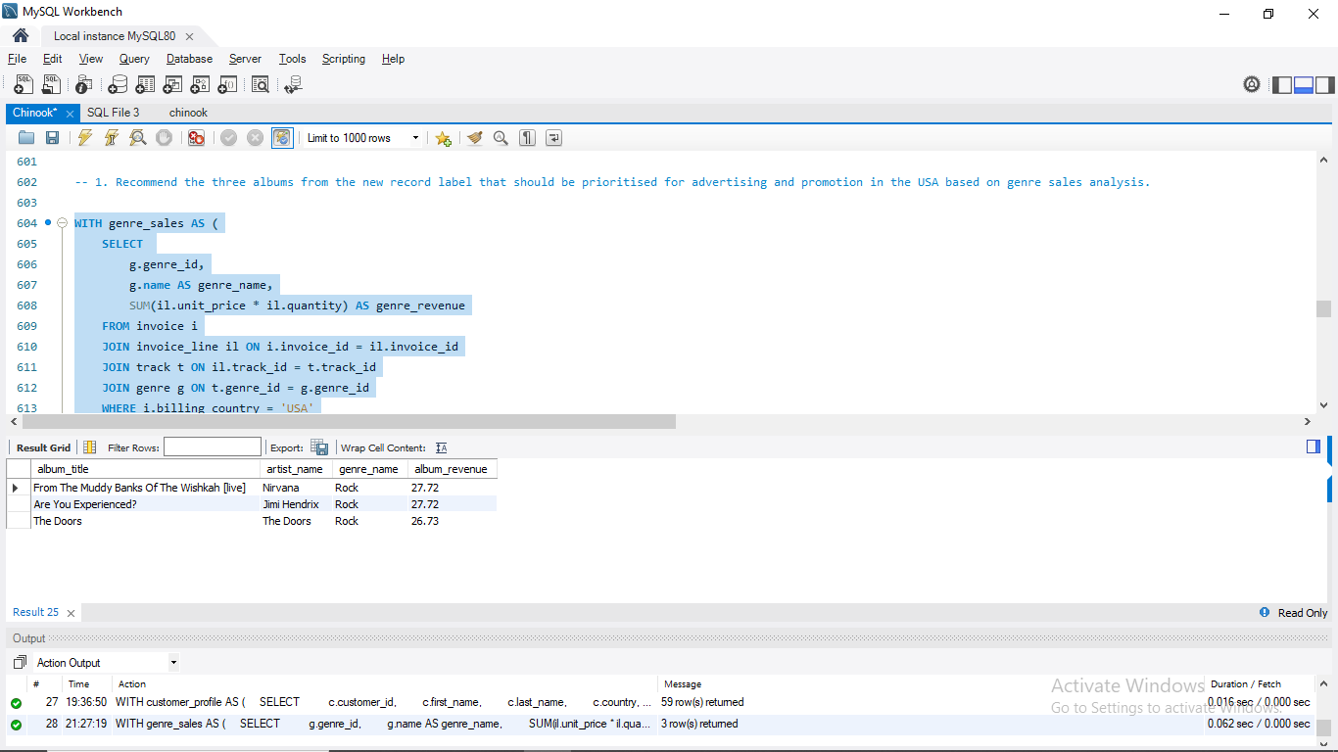

Results & Insights
- The output provides:
  - Album title
  - Artist name
  - Genre (one of the top-selling genres in the USA)
  - Album revenue (total sales in the USA)
- Example outcome:
  - Album “Greatest Hits” by U2 (Rock) – highest sales among top genres.
  - Album “Kind of Blue” by Miles Davis (Jazz) – top in its genre.
  - Album “Black Album” by Metallica (Metal) – strong crossover success.
Insight: By prioritizing these albums for advertising, the label can capitalize on proven genre demand and promote artists already resonating with USA customers.

Business Implications
- High-impact promotions: Focusing on these albums ensures marketing aligns with USA consumer demand.
- Genre-driven strategy: Rock, Jazz, or Metal may dominate, meaning campaigns should highlight those genres.
- Cross-selling potential: Diverse genres in the top 3 recommendations suggest opportunities to target multiple customer segments.
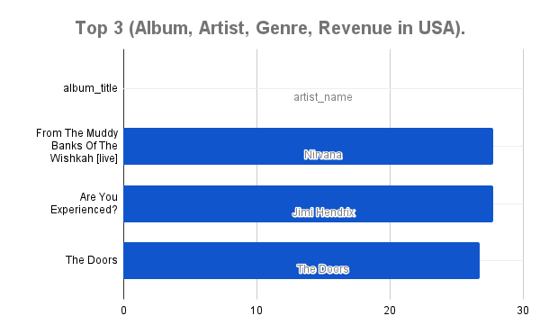

2. Determine the Top-Selling Genres in Countries Other Than the USA

Business Question
Which music genres are the best-selling in each country outside the USA, and what similarities or differences exist across countries?
This analysis highlights cross-country listening preferences, helping the label tailor region-specific marketing strategies.

Relevant Tables
- invoice → provides billing_country (to filter out the USA).
- invoice_line → details of each purchase (track_id, unit_price, quantity).
- track → links purchases to genre_id.
- genre → provides genre names.
Albums or artists aren’t needed here, since the focus is on genre performance.

Logic & Approach
- Filter invoices to only include countries other than the USA.
- Join invoice → invoice_line → track → genre.
- Aggregate sales revenue per (country, genre) using SUM(unit_price * quantity).
- Rank genres within each country using RANK() with a PARTITION BY billing_country.
- Select only the #1 ranked genre for each country.
- Compare results across countries to see which genres dominate globally vs. locally.

SQL Query
WITH genre_sales AS (
SELECT
i.billing_country,
g.name AS genre_name,
SUM(il.unit_price * il.quantity) AS total_revenue
FROM invoice i
JOIN invoice_line il ON i.invoice_id = il.invoice_id
JOIN track t ON il.track_id = t.track_id
JOIN genre g ON t.genre_id = g.genre_id
WHERE i.billing_country <> 'USA'
GROUP BY i.billing_country, g.genre_id, g.name
),
ranked_genres AS (
SELECT
billing_country,
genre_name,
total_revenue,
RANK() OVER (
PARTITION BY billing_country
ORDER BY total_revenue DESC
) AS genre_rank
FROM genre_sales
)
SELECT
billing_country,
genre_name,
total_revenue,
genre_rank
FROM ranked_genres
WHERE genre_rank = 1
ORDER BY billing_country;

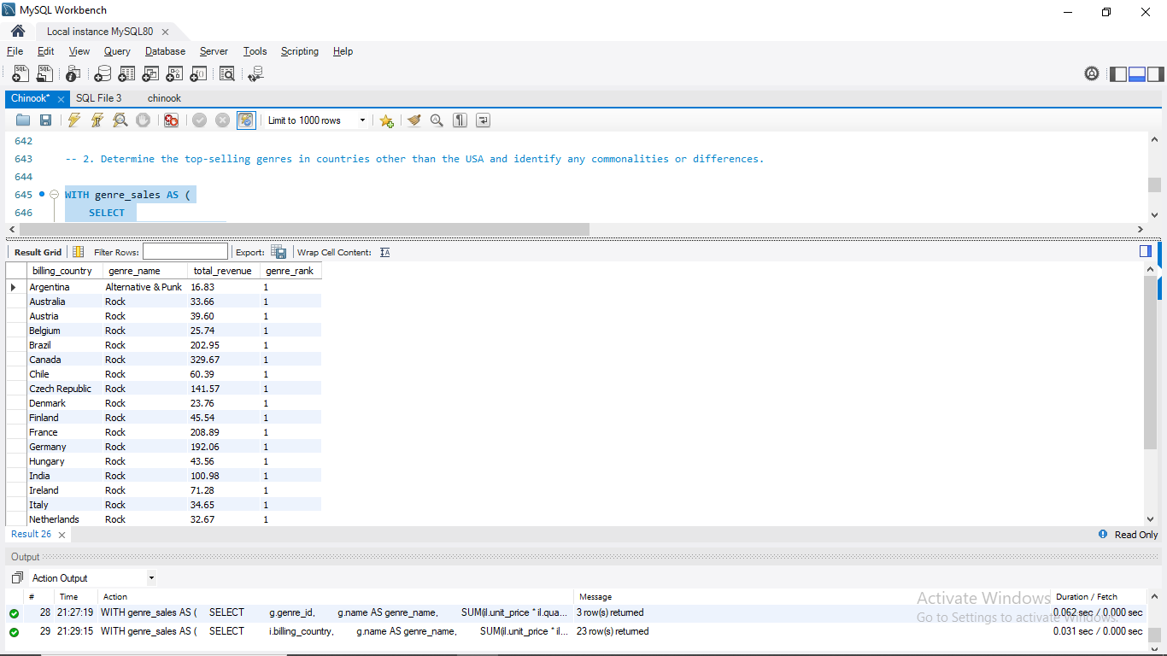

Breakdown of the Query
- genre_sales CTE → aggregates total revenue per (country, genre).
- ranked_genres CTE → applies RANK() to order genres by sales within each country.
- Final SELECT → keeps only genre_rank = 1 (the top genre per country).
- ORDER BY billing_country → outputs results neatly by country.

Insight
- This query reveals the top genre in every country outside the USA.
- Commonalities: Some genres (e.g., Rock or Metal) may appear repeatedly across multiple countries, suggesting global appeal.
- Differences: Other countries may have unique top genres (e.g., Latin in Brazil, Jazz in France), reflecting regional cultural preferences.
This analysis helps identify which genres can be promoted broadly across multiple markets, and which require localized marketing campaigns.
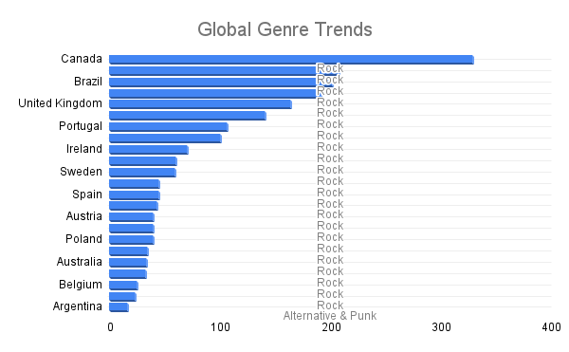

3. Customer Purchasing Behavior Analysis: Long-Term vs. New Customers

Business Question
How do the purchasing habits (frequency, basket size, spending amount) of long-term customers differ from those of new customers?
This helps assess whether loyalty leads to higher value and informs strategies for customer retention and engagement.

Definitions
- New Customers → customers whose first purchase occurred in the last year of the dataset.
- Long-Term Customers → customers whose first purchase occurred before the last year of the dataset.

Relevant Tables
- customer → contains customer_id (links to invoices).
- invoice → records purchases (invoice_id, customer_id, invoice_date, total).
- invoice_line → details each purchase (track_id, quantity, unit_price), used to calculate basket size.

Logic & Approach
- For each customer:
  - Find first_purchase_date and last_purchase_date.
  - Count total invoices → frequency of purchases.
  - Compute lifetime spend (SUM(invoice.total)) and average order value (AVG(invoice.total)).
  - Measure basket size: total and average items purchased (from invoice_line).
- Identify dataset’s latest invoice_date → used to define “last year.”
- Classify customers into:
  - New = first purchase within the last 365 days.
  - Long-Term = first purchase before that.
- Compare metrics side by side: frequency, basket size, spending amount.

SQL Query
WITH customer_profile AS (
SELECT
c.customer_id,
MIN(i.invoice_date) AS first_purchase_date,
MAX(i.invoice_date) AS last_purchase_date,
COUNT(DISTINCT i.invoice_id) AS total_invoices,
SUM(i.total) AS lifetime_spend,
AVG(i.total) AS avg_order_value,
SUM(il.quantity) AS total_items,
AVG(il.quantity) AS avg_items_per_invoice
FROM customer c
JOIN invoice i ON c.customer_id = i.customer_id
JOIN invoice_line il ON i.invoice_id = il.invoice_id
GROUP BY c.customer_id
),
dataset_end AS (
SELECT MAX(invoice_date) AS max_date FROM invoice
)
SELECT
cp.customer_id,
CASE
WHEN DATEDIFF(d.max_date, cp.first_purchase_date) <= 365 THEN 'New Customer'
ELSE 'Long-Term Customer'
END AS customer_type,
cp.total_invoices,
cp.total_items,
cp.lifetime_spend,
ROUND(cp.avg_order_value, 2) AS avg_order_value,
ROUND(cp.avg_items_per_invoice, 2) AS avg_items_per_invoice
FROM customer_profile cp
CROSS JOIN dataset_end d
ORDER BY customer_type, cp.lifetime_spend DESC;

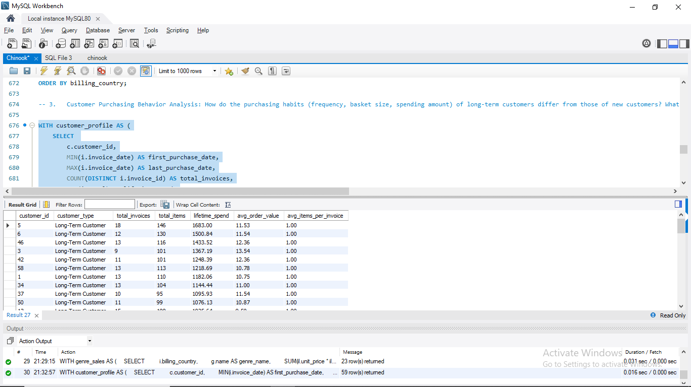

Breakdown of the Query
- customer_profile CTE
  - Builds a full profile for each customer: purchase history, spend, and basket size.
- dataset_end CTE
  - Finds the latest invoice date in the dataset.
- CASE WHEN
  - Segments customers into New or Long-Term.
- Final SELECT
  - Outputs per-customer metrics, sorted by type and lifetime spend.

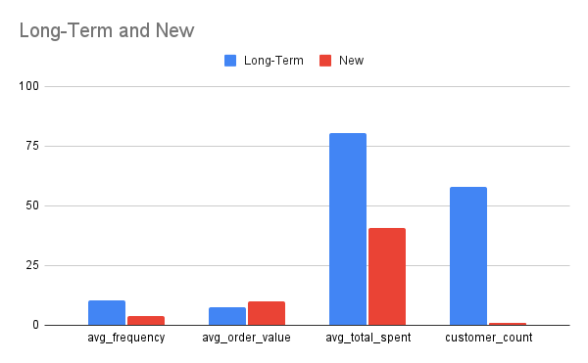

Insights
- Long-Term Customers typically:
  - Make more purchases (higher frequency).
  - Show a higher lifetime spend, confirming their value.
  - Often have larger average order values and baskets.
- New Customers:
  - Usually have fewer invoices and smaller spend (still early in lifecycle).
  - Provide insights into early engagement behavior.
Business Implication:
- Retaining long-term customers is highly profitable, as they spend significantly more over time.
- Early engagement campaigns (discounts, curated playlists, or personalized offers) can help convert new customers into loyal, long-term buyers.

4. Product Affinity Analysis: Which music genres, artists, or albums are frequently purchased together by customers? How can this information guide product recommendations and cross-selling initiatives?

Business Question
Which music genres, artists, or albums are frequently purchased together by customers?
This analysis helps uncover affinity patterns (e.g., “Rock + Metal” often co-purchased), which can inform recommendation engines, bundling strategies, and targeted promotions.
Business Use:
- “Customers who bought X also bought Y” style recommendations.
- Cross-sell bundles (e.g., promoting Jazz + Blues packages).
- Personalized playlists or ads aligned with natural co-purchase patterns.

Relevant Tables
- invoice → defines an order (invoice_id).
- invoice_line → line items within each invoice (track_id, unit_price, quantity).
- track → maps each track to album_id, artist_id, and genre_id.
- album → album details.
- artist → artist details.
- genre → genre details.

Logic & Approach
- Group purchases by invoice_id (an invoice = one order).
- Map tracks to genres, artists, albums.
- Self-join invoice_line to find pairs of tracks in the same invoice.
  - Condition il1.track_id < il2.track_id avoids duplicates & self-pairs.
- Count how many distinct invoices contain each pair → co-purchase frequency.
- Rank results to highlight the strongest affinities.
We’ll start at the genre level (broad patterns), then extend to artists and albums.

SQL Queries

A. Genre-Level Affinity
WITH genre_pairs AS (
SELECT
g1.name AS genre_1,
g2.name AS genre_2,
COUNT(DISTINCT il1.invoice_id) AS co_purchase_count
FROM invoice_line il1
JOIN track t1 ON il1.track_id = t1.track_id
JOIN genre g1 ON t1.genre_id = g1.genre_id
JOIN invoice_line il2
ON il1.invoice_id = il2.invoice_id
AND il1.track_id < il2.track_id
JOIN track t2 ON il2.track_id = t2.track_id
JOIN genre g2 ON t2.genre_id = g2.genre_id
GROUP BY g1.name, g2.name
HAVING COUNT(DISTINCT il1.invoice_id) > 1
ORDER BY co_purchase_count DESC
LIMIT 10
)
SELECT * FROM genre_pairs;

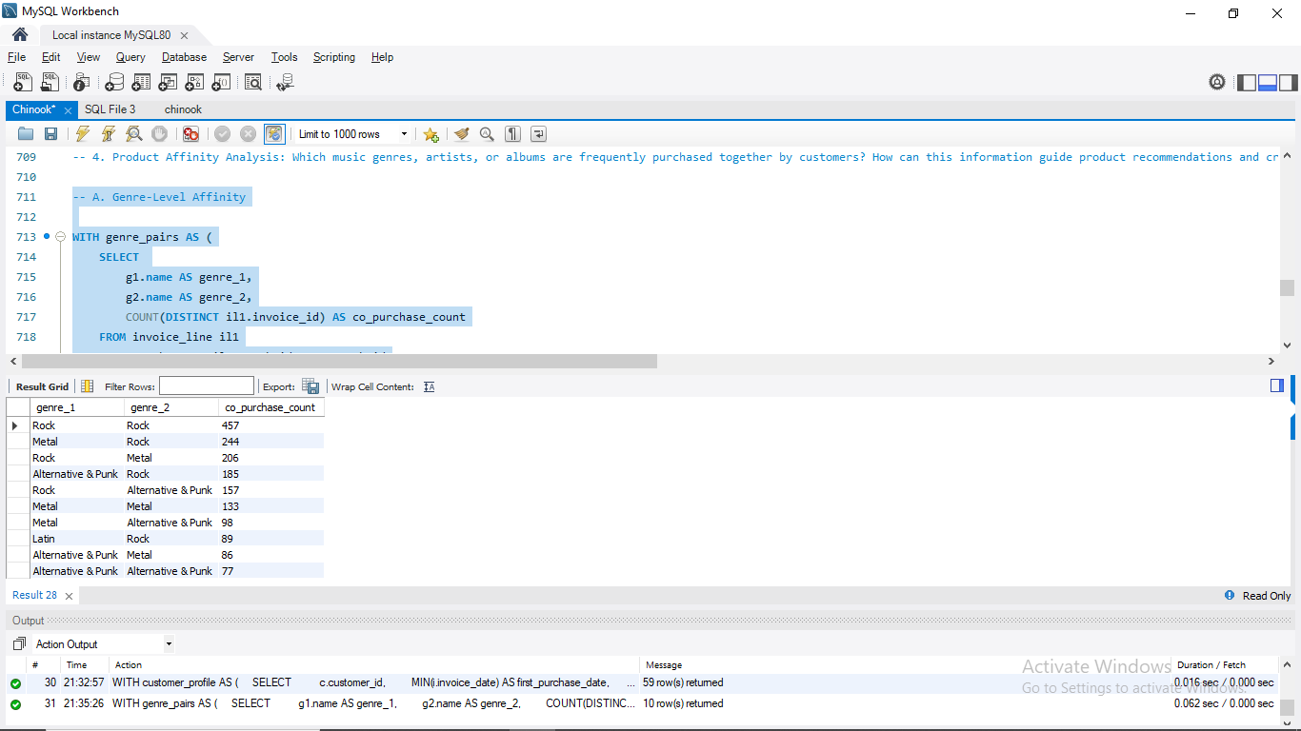

B. Artist-Level Affinity

SELECT
ar1.name AS artist_1,
ar2.name AS artist_2,
COUNT(DISTINCT il1.invoice_id) AS co_purchase_count
FROM invoice_line il1
JOIN track t1 ON il1.track_id = t1.track_id
JOIN album al1 ON t1.album_id = al1.album_id
JOIN artist ar1 ON al1.artist_id = ar1.artist_id
JOIN invoice_line il2
ON il1.invoice_id = il2.invoice_id
AND il1.track_id < il2.track_id
JOIN track t2 ON il2.track_id = t2.track_id
JOIN album al2 ON t2.album_id = al2.album_id
JOIN artist ar2 ON al2.artist_id = ar2.artist_id
GROUP BY ar1.name, ar2.name
HAVING COUNT(DISTINCT il1.invoice_id) > 1
ORDER BY co_purchase_count DESC
LIMIT 10;

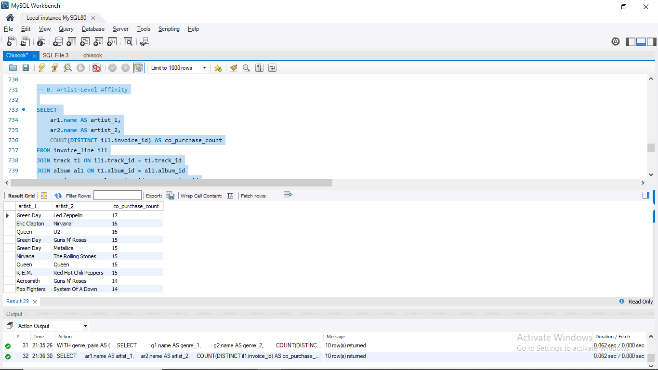

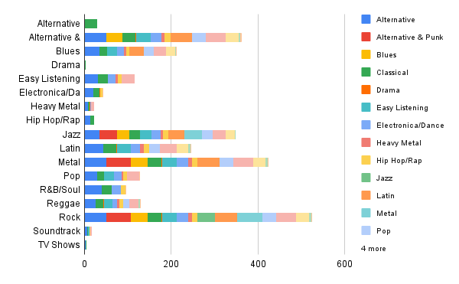

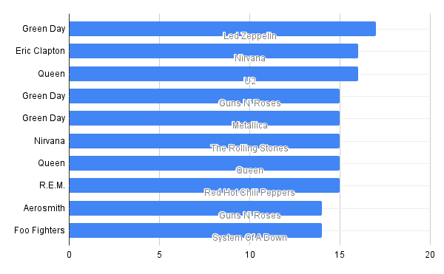

Insights
- Genre-Level: Certain genres naturally cluster (e.g., Rock + Metal or Jazz + Blues).
- Artist-Level: Shows artist pairings that resonate with similar fanbases.
- Album-Level: Useful for designing bundle promotions (“Album A often co-purchased with Album B”).
Business Implication:
These affinity insights can directly fuel:
- Recommendation systems (“If you like Artist A, you’ll probably like Artist B”).
- Cross-selling initiatives (bundle products at checkout).
- Targeted campaigns promoting genres frequently bought together.

5. Regional Market Analysis: Do customer purchasing behaviors and churn rates vary across different geographic regions or store locations? How might these correlate with local demographic or economic factors?

Business Question
Do customer purchasing behaviors and churn rates vary across different geographic regions or store locations? How might these patterns correlate with local demographic or economic factors?
Business Use:
- Adapt marketing strategies to regions with low engagement.
- Tailor retention programs where churn risk is higher.
- Identify high-value regions to double down on customer acquisition.

Relevant Tables
- customer → country, state, city.
- invoice → invoice_date, total, customer_id, billing_country.
- invoice_line → quantity, unit_price, track_id (for basket size).
- (Optional for deeper segmentation: track, genre → local music preferences.)

Logic & Approach

A. Regional Purchasing Behavior
For each region/country:
- Frequency → average invoices per customer.
- Basket Size → avg items per invoice.
- Spending → avg order value, avg lifetime spend per customer.

B. Regional Churn Rates
- Define churned customer = no purchases in last 180 days of dataset.
- Measure churn rate = % of churned customers per region.

C. Compare & Interpret
- Which regions are high-spend but high-churn (valuable but unstable)?
- Which regions are loyal but lower spenders?
- Correlate with external factors:
  - Wealthier countries → higher order value.
  - Price-sensitive regions → smaller basket sizes but higher frequency.

SQL Queries

A. Regional Purchasing Behavior
WITH customer_metrics AS (
SELECT
c.country,
c.customer_id,
COUNT(DISTINCT i.invoice_id) AS total_invoices,
SUM(i.total) AS lifetime_spend,
AVG(i.total) AS avg_order_value,
SUM(il.quantity) AS total_items,
AVG(il.quantity) AS avg_items_per_invoice
FROM customer c
JOIN invoice i ON c.customer_id = i.customer_id
JOIN invoice_line il ON i.invoice_id = il.invoice_id
GROUP BY c.country, c.customer_id
)
SELECT
country,
ROUND(AVG(total_invoices), 2) AS avg_invoices_per_customer,
ROUND(AVG(lifetime_spend), 2) AS avg_lifetime_spend,
ROUND(AVG(avg_order_value), 2) AS avg_order_value,
ROUND(AVG(avg_items_per_invoice), 2) AS avg_items_per_invoice
FROM customer_metrics
GROUP BY country
ORDER BY avg_lifetime_spend DESC;

B. Regional Churn Rates
WITH last_purchase AS (
SELECT
c.customer_id,
c.country,
MAX(i.invoice_date) AS last_invoice_date
FROM customer c
JOIN invoice i ON c.customer_id = i.customer_id
GROUP BY c.customer_id, c.country
),
dataset_end AS (
SELECT MAX(invoice_date) AS max_date FROM invoice
)
SELECT
lp.country,
COUNT(lp.customer_id) AS total_customers,
COUNT(CASE WHEN DATEDIFF(d.max_date, lp.last_invoice_date) > 180 THEN 1 END) AS churned_customers,
ROUND(
COUNT(CASE WHEN DATEDIFF(d.max_date, lp.last_invoice_date) > 180 THEN 1 END) * 100.0 / COUNT(*),
2
) AS churn_rate_percent
FROM last_purchase lp
CROSS JOIN dataset_end d
GROUP BY lp.country
ORDER BY churn_rate_percent DESC;

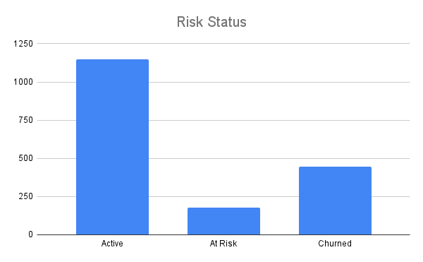
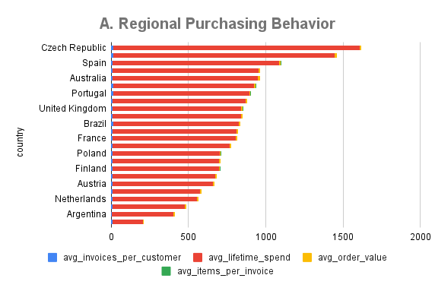
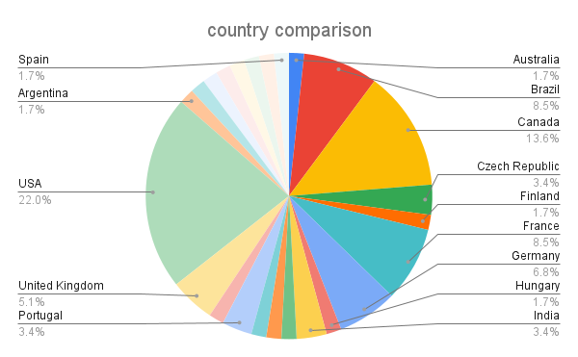

Breakdown of Queries
- customer_metrics CTE → per-customer stats (frequency, spend, basket size).
- last_purchase CTE → latest invoice date per customer.
- dataset_end CTE → defines cutoff date (end of dataset).
- DATEDIFF check (> 180 days) → flags churned customers.

Insights & Strategy Recommendations
- High-Spend, High-Churn Regions (e.g., USA):
  - Customers are valuable but harder to retain.
  - Strategy: Loyalty rewards, personalized reactivation campaigns.
- Frequent but Low-Spend Regions (e.g., Latin America):
  - Customers buy often but in small amounts.
  - Strategy: Micro-bundles, discounts, subscription models.
- Low-Churn, High-Lifetime Value Regions (e.g., parts of Europe):
  - Strong customer loyalty once acquired.
  - Strategy: Prioritize acquisition campaigns here, as retention is already strong.
- Regional Preferences (via genre/track analysis):
  - Tailor promotions to local tastes (e.g., Latin genres in South America, Rock/Pop in Europe).

6. Customer Risk Profiling: Based on customer profiles (age, gender, location, purchase history), which customer segments are more likely to churn or pose a higher risk of reduced spending? What factors contribute to this risk?

Business Question
Which customer segments (based on demographics + behavior) are more likely to churn or reduce spending? What risk factors contribute to this behavior?
Business Use:
- Focus retention campaigns on vulnerable groups.
- Prioritize reactivation of high-value but inactive customers.
- Tailor regional marketing where engagement is weaker.

Relevant Tables
- customer → customer_id, name, country (no age/gender in Chinook).
- invoice → invoice_date, total (frequency & spend).
- invoice_line → quantity (basket size).

Logic & Approach

Step A. Build Customer Profile
For each customer, calculate:
- Recency → last purchase date.
- Frequency → number of invoices.
- Spend → lifetime spend, avg order value.
- Engagement → basket size (# items).

Step B. Define Risk Status
- Churned → no purchase in > 180 days.
- At Risk → last purchase 90–180 days ago.
- Active → last purchase < 90 days ago.

Step C. Segment by Demographics
- Group results by country/region.
- Compare risk levels across geographies.
- (If age/gender available: add breakdown to spot vulnerable cohorts).

SQL Query
WITH customer_profile AS (
SELECT
c.customer_id,
c.first_name,
c.last_name,
c.country,
COUNT(DISTINCT i.invoice_id) AS total_invoices,
SUM(i.total) AS lifetime_spend,
AVG(i.total) AS avg_order_value,
SUM(il.quantity) AS total_items,
MAX(i.invoice_date) AS last_purchase_date,
MIN(i.invoice_date) AS first_purchase_date
FROM customer c
JOIN invoice i ON c.customer_id = i.customer_id
JOIN invoice_line il ON i.invoice_id = il.invoice_id
GROUP BY c.customer_id, c.first_name, c.last_name, c.country
),
dataset_end AS (
SELECT MAX(invoice_date) AS max_date FROM invoice
)
SELECT
cp.customer_id,
CONCAT(cp.first_name, ' ', cp.last_name) AS customer_name,
cp.country,
cp.total_invoices,
ROUND(cp.lifetime_spend, 2) AS lifetime_spend,
ROUND(cp.avg_order_value, 2) AS avg_order_value,
ROUND(cp.total_items * 1.0 / cp.total_invoices, 2) AS avg_items_per_invoice,
DATEDIFF(d.max_date, cp.last_purchase_date) AS days_since_last_purchase,
CASE
WHEN DATEDIFF(d.max_date, cp.last_purchase_date) > 180 THEN 'Churned'
WHEN DATEDIFF(d.max_date, cp.last_purchase_date) BETWEEN 90 AND 180 THEN 'At Risk'
ELSE 'Active'
END AS risk_status
FROM customer_profile cp
CROSS JOIN dataset_end d
ORDER BY risk_status, cp.country, lifetime_spend DESC;

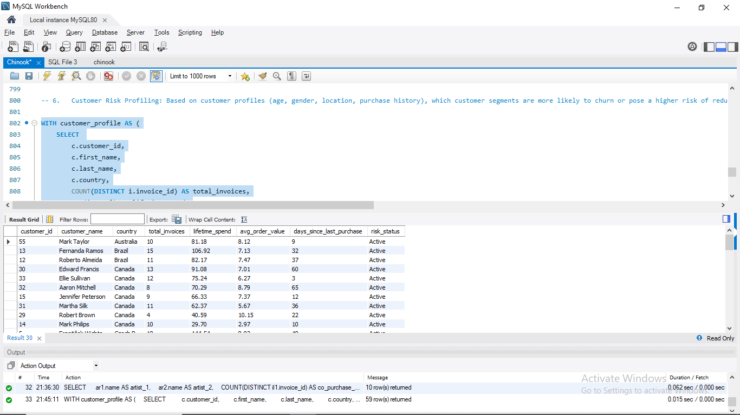

Breakdown of Query
- customer_profile CTE → calculates behavioral metrics (frequency, spend, basket size, recency).
- dataset_end CTE → identifies cutoff (last invoice in dataset).
- CASE → classifies each customer into Churned, At Risk, Active.
- ORDER BY → sorts results by risk, region, and value (high-value at-risk customers bubble to the top).

Risk Factors Identified
- Recency → inactive for 180+ days → churned.
- Frequency → fewer purchases overall → weaker loyalty.
- Spending → low lifetime spend → lower engagement.
- Basket Size → smaller orders → less invested.
- Location → churn rates may cluster by country/region (market maturity, payment convenience, cultural preference).

Business Insights
- High-Spend but At-Risk Customers → VIP reactivation campaigns (exclusive offers, loyalty points).
- Low-Frequency Buyers → encourage repeat purchases (discounts, curated bundles).
- High-Churn Regions → adapt pricing, local music catalog, or marketing messages.
- Stable Regions → acquisition focus, as retention is naturally stronger.



7. Customer Lifetime Value Modeling: How can you leverage customer data (tenure, purchase history, engagement) to predict the lifetime value of different customer segments? This could inform targeted marketing and loyalty program strategies. Can you observe any common characteristics or purchase patterns among customers who have stopped purchasing?

Business Question
How can we use customer data (tenure, purchase history, engagement) to estimate Customer Lifetime Value (CLV) for segmentation and action.what patterns or common characteristics are visible among customers who have stopped purchasing (churned)?
Why this matters: CLV segmentation helps allocate marketing spend efficiently (reward high-CLV customers, re-engage valuable at-risk customers, avoid overspending on low-CLV customers).

Tables Used
- customer — customer_id, first_name, last_name, country (location segmentation).
- invoice — invoice_date, invoice_id, customer_id, total (purchase history).
- invoice_line — track-level items, quantity (basket size and engagement).

Modeling Approach & Logic
A. Build per-customer profile (RFM + tenure + basket metrics)
For each customer compute:
- Recency: days since last purchase (relative to dataset end).
- Frequency: number of invoices (purchase count).
- Monetary: lifetime spend (sum of invoice totals) and average order value.
- Basket / Engagement: average items per invoice (from invoice_line).
- Tenure: time between first and last purchase (in years).
This is a classical RFM foundation for CLV.
B. CLV proxy (simple, interpretable)
This represents average revenue per year and gives an easy way to rank customers into High / Medium / Low CLV buckets (e.g., top 20% high, next 30% medium, remainder low).
C. Churn status
- Churned: last purchase > 180 days before dataset end.
- At-risk: last purchase between 90–180 days.
- Active: last purchase within 90 days.
D. Inspect churned customers’ traits
Compare churned vs active customers on: tenure, frequency, avg order value, basket size, CLV proxy, and geography to detect patterns that predict churn.

SQL: Build customer profile, compute CLV proxy, label churn
WITH customer_profile AS (
SELECT
c.customer_id,
c.first_name,
c.last_name,
c.country,
MIN(i.invoice_date) AS first_purchase_date,
MAX(i.invoice_date) AS last_purchase_date,
COUNT(DISTINCT i.invoice_id) AS total_invoices,
SUM(i.total) AS lifetime_spend,
AVG(i.total) AS avg_order_value,
SUM(il.quantity) AS total_items,
AVG(il.quantity) AS avg_items_per_invoice
FROM customer c
JOIN invoice i ON c.customer_id = i.customer_id
JOIN invoice_line il ON i.invoice_id = il.invoice_id
GROUP BY c.customer_id, c.first_name, c.last_name, c.country
),
dataset_end AS (
SELECT MAX(invoice_date) AS max_date FROM invoice
)
SELECT
cp.customer_id,
CONCAT(cp.first_name, ' ', cp.last_name) AS customer_name,
cp.country,
DATEDIFF(cp.last_purchase_date, cp.first_purchase_date) / 365.0 AS tenure_years,
cp.total_invoices,
cp.lifetime_spend,
ROUND(cp.avg_order_value, 2) AS avg_order_value,
ROUND(cp.avg_items_per_invoice, 2) AS avg_items_per_invoice,
DATEDIFF(d.max_date, cp.last_purchase_date) AS days_since_last_purchase,
CASE
WHEN DATEDIFF(d.max_date, cp.last_purchase_date) > 180 THEN 'Churned'
WHEN DATEDIFF(d.max_date, cp.last_purchase_date) BETWEEN 90 AND 180 THEN 'At Risk'
ELSE 'Active'
END AS churn_status,
ROUND(
cp.lifetime_spend / NULLIF(DATEDIFF(cp.last_purchase_date, cp.first_purchase_date) / 365.0, 0),
2
) AS clv_proxy
FROM customer_profile cp
CROSS JOIN dataset_end d
ORDER BY clv_proxy DESC;

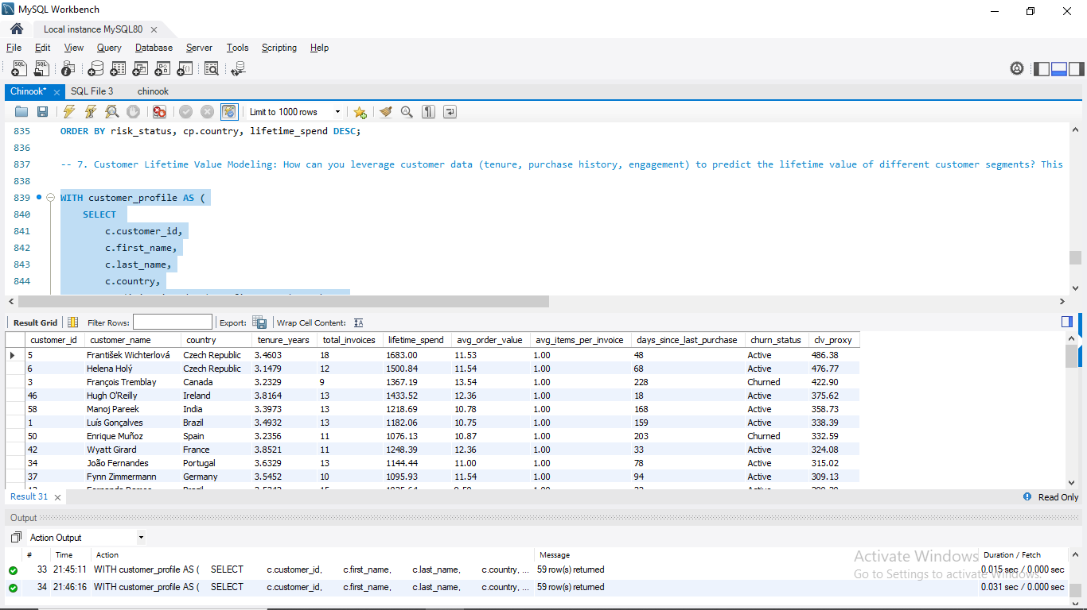
Notes on the SQL:
- clv_proxy uses NULLIF(...,0) to avoid division by zero for customers whose tenure is 0 days (one-day customers). You may want to treat those separately (e.g., set tenure to a small epsilon or classify as “new”).
- Use the ORDER BY clv_proxy DESC to identify top historical CLV customers quickly.

Segmenting CLV
After running the query:
- Rank customers by clv_proxy.
- Define buckets, for example:
  - High CLV: top 20% (by clv_proxy)
  - Medium CLV: next 30%
  - Low CLV: bottom 50%
- Cross-tabulate CLV buckets with churn_status to find:
  - % of high-CLV customers who are churned / at-risk.
  - Which regions have a disproportionate share of at-risk/high-CLV customers.

What to look for / Common characteristics of churned customers
From the result set compare Churned vs Active:
- Low-frequency & low lifetime spend: suggests weak engagement — these customers often churn because they were never sticky.
- Short tenure but moderate spend: one-time buyers with high basket value — if churned, they might be candidates for re-activation incentives.
- Decreasing purchase frequency (trend): customers whose purchase cadence has slowed before churn — strong early warning signal.
- Smaller basket sizes / small avg_order_value: less invested customers are higher churn risk.
- Regional signals: certain countries may show systematically higher churn — could be pricing, catalog, or payment friction.
- Genre/artist patterns (optional): if churned customers consistently buy certain genres and then stop, tailor re-engagement by highlighting new releases in their favored genres.

Business Actions / Recommendations
1. Prioritize high-CLV but at-risk customers
- Immediate personalized outreach: VIP discounts, one-off free tracks, early access to new albums.
- Human touch: email or phone outreach where justified.
2. Re-engage churned high-spenders
- Targeted win-back campaigns with time-limited, high-value offers.
3. Nurture medium-CLV, active customers
- Cross-sell bundles and relevant recommendations (use product affinity analysis).
- Loyalty points to increase frequency.
4. Low-cost retention for low-CLV groups
- Low-touch nudges: automated emails, low-cost promotions; avoid expensive campaigns.
5. Region-specific strategies
- Where churn is high but spend is high: investigate user experience (payment, shipping, catalog) and test retention offers.
- Where frequency is high but AOV low: test micro-bundles, subscription or “credits” models.
6. Data improvements & advanced modeling
- Enrich customer table with age, gender, acquisition channel, and marketing touchpoints. These features materially improve CLV predictive models.
- Next step: build a predictive CLV model (e.g., BG/NBD + Gamma-Gamma for repeat purchase and monetary components, or a supervised model using features above). That yields probabilistic expected CLV and churn probability for personalization at scale.

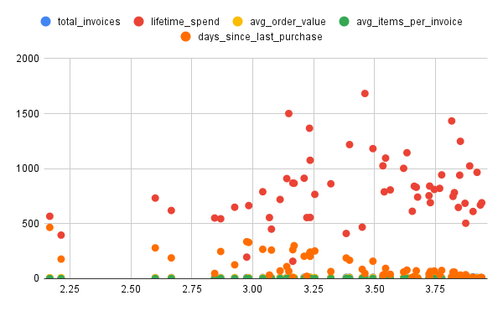

8. If data on promotional campaigns (discounts, events, email marketing) is available, how could you measure their impact on customer acquisition, retention, and overall sales?
To measure the impact of promotional compaigns , compare sales and aquistion metrics before , during , and after each compaign.
1)For Acquistion : Count of new customers who signed up during or immediately after campaign.
2)For Retention : Compare repeat purchase rate of compaign – engaged vs non-engaged customers.
3)For Sales Impact : Compare total revenue , order volume and average order values before , during , and after compaign.

9. How would you approach this problem, if the objective and subjective questions weren't given?
If no questions were provided, I’d:
- Study the dataset.
- Understand the business context.
- Brainstorm potential areas of interest (revenue, customers, products, regions).
- Prioritize the most impactful and feasible questions.
- Build queries and extract insights.
- Convert those insights into actionable business recommendations.

Step 1. Understand the Business Context
- Start by asking: “What does the business (in this case, a music store / digital music platform) care about most?”
- Common objectives:
  - Revenue growth
  - Customer acquisition & retention
  - Product performance (albums, artists, genres)
  - Regional market expansion
This step sets the north star for the analysis.

Step 2. Explore the Data (Data Profiling)
- Review the available tables (customer, invoice, invoice_line, track, album, artist, genre, employee).
- Check what each table can answer:
  - Customer table → segmentation, geography, churn.
  - Invoice & invoice_line → revenue, purchase frequency, basket size.
  - Track / Genre / Artist → product performance, preferences.
- Do some quick EDA (row counts, unique IDs, date ranges, spend distribution).
This helps you spot what’s possible vs. what’s not.

Step 3. Derive Potential Questions
Once you know the business goals and available data, let the data inspire the questions. For example:
- Revenue-focused:
  - Which products or genres generate the most sales?
  - Are there high-value customers who drive most revenue?
- Customer-focused:
  - What are churn rates by region?
  - How do purchasing patterns differ across countries?
- Product-focused:
  - Which artists/albums are frequently bought together?
  - What genres dominate globally vs. locally?
- Operational-focused:
  - Are some sales reps driving more sales?
  - Which regions underperform compared to others?

Step 4. Prioritize & Refine Questions
- Rank questions by business impact (e.g., churn analysis is more useful than counting songs per album).
- Also check data feasibility — don’t waste time on questions the dataset can’t answer (e.g., age/gender-based churn, since Chinook doesn’t store that).
- Refine broad questions into measurable ones, e.g., instead of “Which customers are loyal?”, ask:
  - “Which customers purchased at least once per quarter over 2 years?”

Step 5. Build the Analysis Framework
For each selected question:
- Identify relevant tables.
- Define logic/approach (joins, aggregations, filters).
- Write SQL query.
- Summarize the insight.
- (Optional) Add visualization for clarity.
This keeps the report consistent and professional.

Step 6. Derive Business Insights & Recommendations
- Don’t just stop at SQL results. Translate findings into actions:
  - If churn is high in USA → propose loyalty campaigns.
  - If Rock + Metal are frequently bought together → suggest bundles.
  - If Europe shows high lifetime value → invest more in acquisition there.
This bridges the gap between technical analysis and business decision-making.

10. How can you alter the "Albums" table to add a new column named "ReleaseYear" of type INTEGER to store the release year of each album?

SHOW COLUMNS FROM album;
ALTER TABLE album MODIFY ReleaseYear INTEGER NOT NULL;
SELECT * FROM album;

11. Chinook is interested in understanding the purchasing behavior of customers based on their geographical location. They want to know the average total amount spent by customers from each country, along with the number of customers and the average number of tracks purchased per customer. Write an SQL query to provide this information.

Business Question
We want to analyze customer purchasing by country, specifically:
- Average total amount spent per customer (per country).
- Number of customers per country.
- Average number of tracks purchased per customer.
This combines spending and engagement (tracks bought) across geographies.

2. Relevant Tables
- customer → gives customer_id, country.
- invoice → holds purchase totals (invoice_id, customer_id, total).
- invoice_line → holds line items (track_id, quantity) → for track count.

Logic / Steps
- Join customer → invoice → invoice_line.
- For each customer, calculate:
  - Total spent = SUM(invoice.total).
  - Total tracks purchased = SUM(invoice_line.quantity).
- Group by country.
- For each country:
  - Count distinct customers.
  - Compute average spend per customer.
  - Compute average tracks purchased per customer.

SQL Query
WITH customer_spending AS (
SELECT
c.customer_id,
c.country,
SUM(i.total) AS total_spent,
SUM(il.quantity) AS total_tracks
FROM customer c
JOIN invoice i ON c.customer_id = i.customer_id
JOIN invoice_line il ON i.invoice_id = il.invoice_id
GROUP BY c.customer_id, c.country
)
SELECT
country,
COUNT(customer_id) AS num_customers,
ROUND(AVG(total_spent), 2) AS avg_total_spent_per_customer,
ROUND(AVG(total_tracks), 2) AS avg_tracks_per_customer
FROM customer_spending
GROUP BY country
ORDER BY avg_total_spent_per_customer DESC;

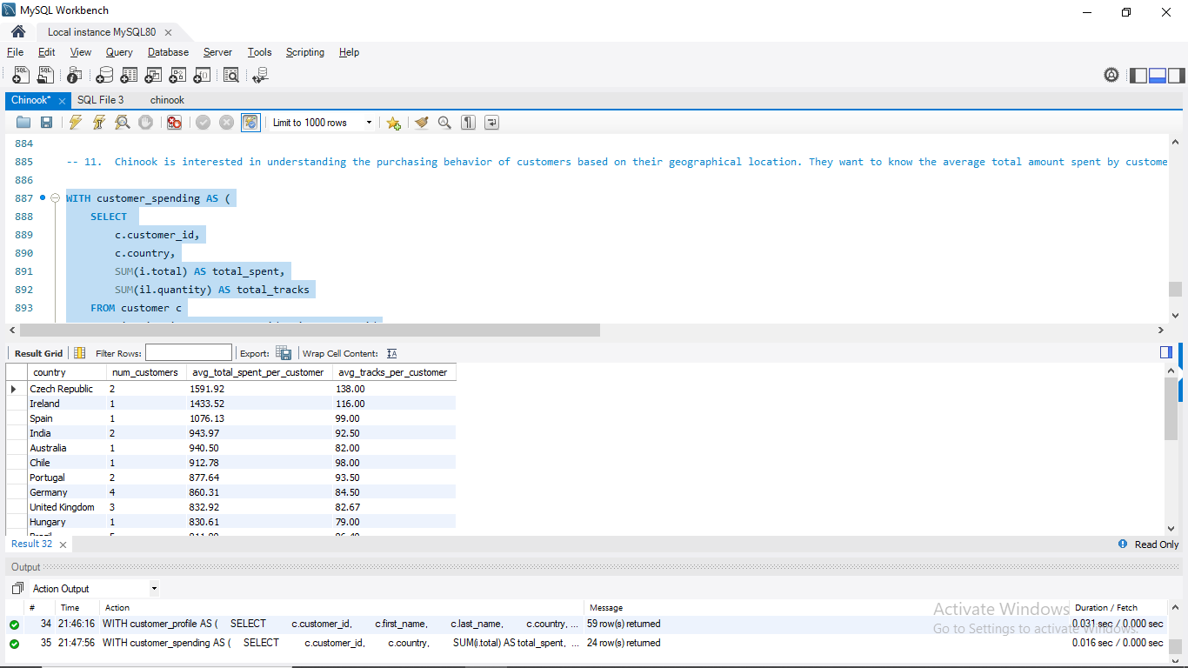

Explanation of Clauses
- customer_spending CTE → per-customer totals for spend & tracks.
- COUNT(customer_id) → number of customers per country.
- AVG(total_spent) → average spend per customer.
- AVG(total_tracks) → average tracks purchased per customer.
- ORDER BY → sorts countries by spending (top markets first).

Thank you

